Create a Free Weebly Account

1.) Navigate to www.education.weebly.com
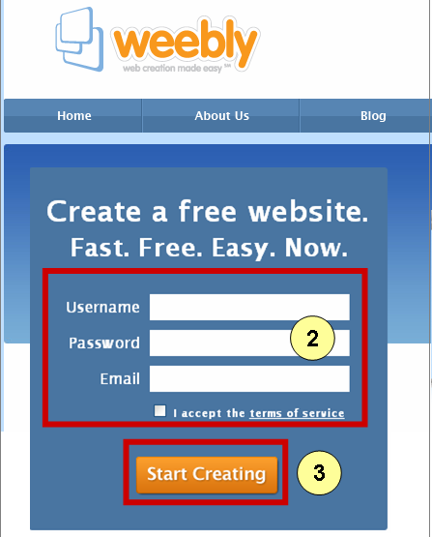
2.) Type in a User Name, Password, and your Email address.
Check the "I accept the terms of service" checkbox.
3.) Click on the "Start Creating" button.

Create and Name Your New Website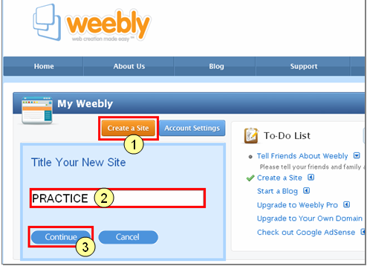
1.) Click on the "Create a Site" button. 2.) Give your site a Name.
3.) Click on the "Continue" button.

Weebly Overview: Tab Contents

When creating your web site, CLICK-AND_DRAG a choice (from the icons shown at the TOP of the Weebly screen) down into the blank work area .
Clicking on a different Menu choice on the TOP LEFT (Basic, Multimedia, Revenue and More) will display a whole new set of icons / choices.
Also at the TOP of the screen are four TABS that you will want to explore: Elements, Designs, Pages, and Settings.
Each Tab serves a different purpose:
"Elements" are the details you want to appear on your web page(s):
Text, Titles, Pictures, etc.
"Designs" are the Graphics - color, placement of menus, etc. that affect the overall appearance of your web site.
"Pages" are like pages in a book. Each 'page' on a web site is a new blank screen that you can fill.
"Settings" have to do with the whole site. In the beginning, you can just accept the defaults.
Captured below are the different Menus and Tabs - and what displays when you click on each one. Scroll down to see all the choices, and get a sense of what you have available.
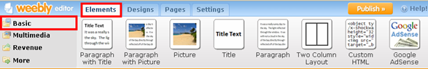
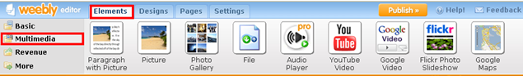
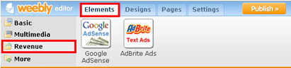
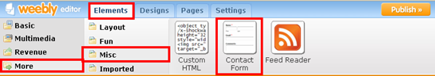
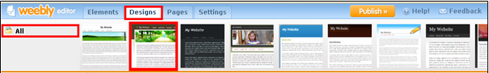
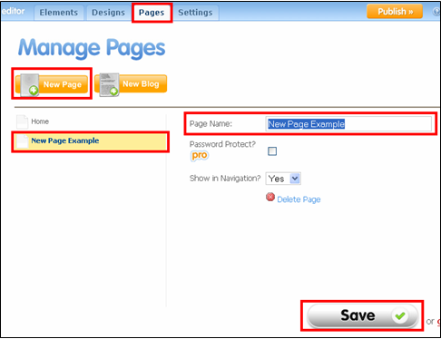
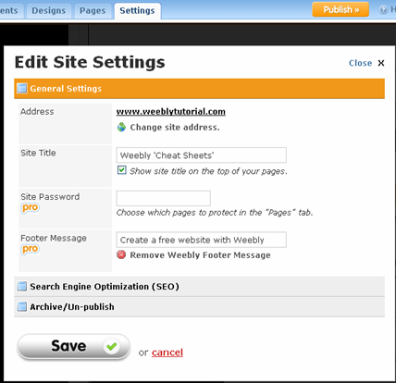

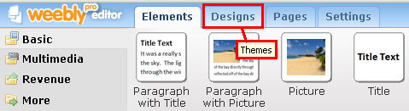

Begin by Choosing a Design from the Designs Tab
Look at the top of your Weebly screen, and notice that one tab is currently white (active) while the other tabs are currently blue (inactive).
To switch between tabs, and to be able to see the choices available under each one, simply click on the label (text) on the tab.
In this case, we want to begin creating your website by clicking on the "Designs" tab.
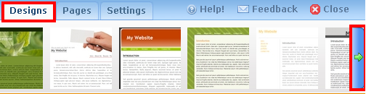

After Clicking on the Designs Tab, You Can Choose a Different Design Than the Weebly Default Design
1.) When you select the Designs tab, the tab will turn white, and a long row of possible new website designs will appear.
2.) Resting your mouse over any design for a moment will allow you to try out that particular design on your website.
3.) At the far right of the row, there is a green arrow. Clicking on the arrow will display still more designs. Note that you can click the arrow multiple times for more choices.
4.) Select a design that is pleasing to you by clicking on the design. Your screen will change to reflect the new design that you've chosen.
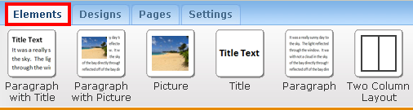

Return to the ElementsTab to Continue Your Work
Once you've decided on the basic overall website design (color, look and feel, and placement of the menu), return to the "Elements" tab to continue working on your website.
Click on "Elements" to select it. The Elements tab is now white (active) and the Design tab has returned to blue (inactive).
And the menu of choices has changed.

Click on Elements to Add Content to Your Page
Once you've decided on the basic overall website design (color, look and feel, and placement of the menu), return to the "Elements" tab to continue working on your website.
Click on "Elements" to select it. The Elements tab is now white (active) and the Design tab has returned to blue (inactive).
And the menu of choices has changed.
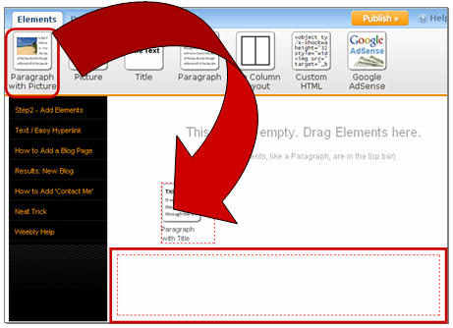

Drag-and-Drop A Paragraph With a Title
At the top of the screen, there are several icons in a row. Each is a separate type of item that can be dragged-and-dropped down into the blank work area.
The first item, all the way to the left, is "Paragraph with Title". Click on it to select it, then - holding the left mouse button down continually, drag-and-drop the item down into the work area. Release the mouse and an empty paragraph with a dummy title will appear.
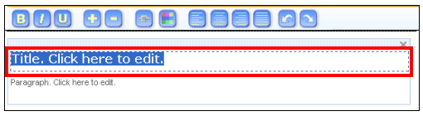

Click On Title Area to Edit The Title Text
Click On Title Area to Edit The Title Text. The words should turn blue. Once the title is highlighted, you can type over the text, replacing it with anything that you want.
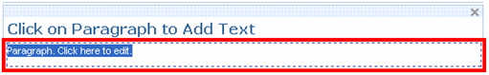

Click on Paragraph to Add Text
Click in the lower box area that says: "Paragraph." The text should turn blue. Once the text is highlighted, you can type over it, replacing it with any words that you want.
Hitting ENTER or RETURN will take you to a new line, allowing you to create additional paragraphs.

Add A Picture
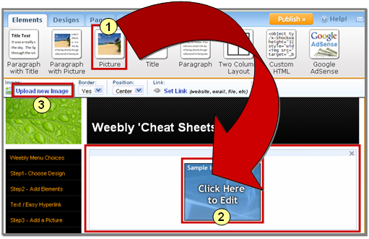
1.) From the Elements tab, select the Picture icon.
2.) Drag-and-Drop the Picture icon down into the work area.
Click on the blue square marked "Click here to Edit".
3.) A new tool bar appears. Click on the words: "Upload new Image".
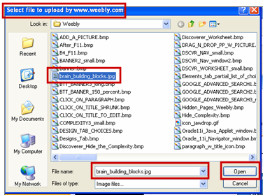

Select an Image File to Upload
A Dialog box opens. Select an image file by clicking on it. It will turn blue, and the name of the file will appear in the "File Name" box.
Click the "Open" button.
It will take a few seconds for the file to upload and the picture to appear on your screen.
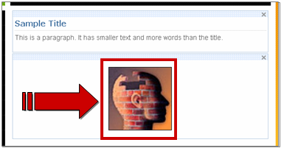

Add a New Page
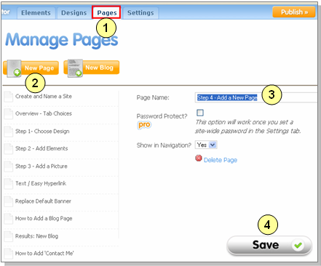

How to Add a New Weebly Page to Your Website
1.) Click on the "Pages" tab.
2.) Click on the orange "New Page" button.
3.) Fill in the new Page Name.
4.) Click the "Save" button.
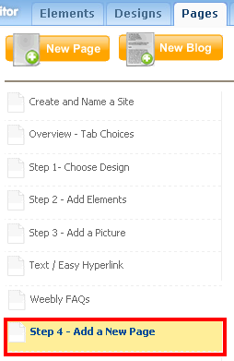

The New Page Appears at the Bottom of Your List of Pages
Note where the new page appears by default - at the bottom of the list.
If this is not where you want it, you will have to Drag-and-Drop the new page up to the new location.
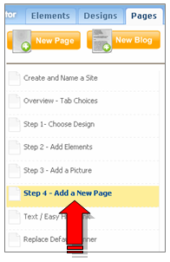

To Make Changes to a Published Site, EDIT the Site
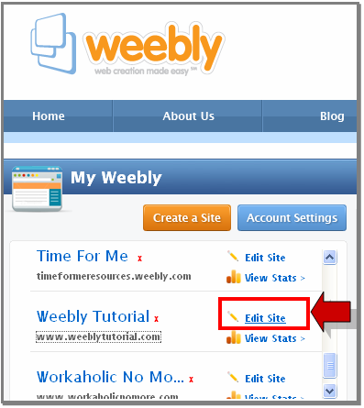

Edit Site
Look for the Pencil. It's subtle, and easy to miss, but that's your door back in
to make changes.

This page shows the Text Editing Toolbar as well as examples of Text.

Text Toolbar Choices from left to right
B = Bold I = Italics U = Underline + = Increase Text Size - = Decrease Text Size
Chain = Link (See directions below on how to create a Link to another Website)
Colors = Text Colors, Left Justify, Center, Right Justify, Full Justify,
Arrows = Undo, Redo
This is a 'Paragraph' (without a Title) from the Basic - Elements menu that was dragged and dropped into a Two Column Layout.
Iit can be more than one paragraph.
When you are typing / editing text, the Text Toolbar will appear, allowing you to modify your text.

This is text that has been hyper-linked to the Barbara Sher website.
Directions shown below.

Paragraph with Picture
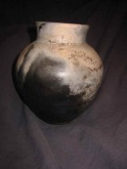
This is an example of what a 'Paragraph with a Picture' looks like when it's dragged-and-dropped into the work area.

The Text Toolbar includes the Hyperlink button, which is used to link to another web site or to a video on Youtube, etc.
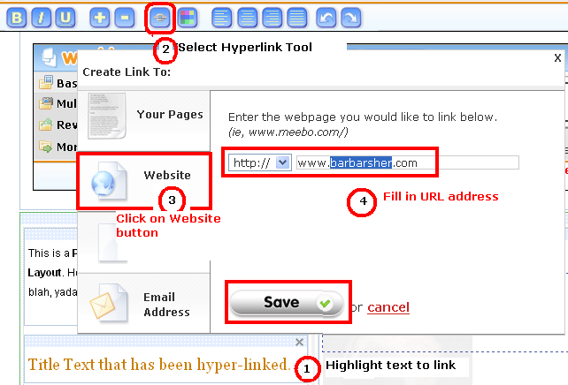

Most Weebly Designs Have a Default Image That Can Be Changed
Most Weebly design templates have some type of default image displayed. That image can be changed.
Click on the header image to open a Dialog box that allows you to Upload a new replacement image.
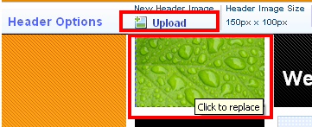

The New Uploaded Image Will Replace the Old Image
The new image should be the same size and scale as the original header image or it will be tiled. (Note bottom of image shown here.)

Most Weebly Designs Have a Default Image That Can Be Changed
Most Weebly design templates have some type of default image displayed. That image can be changed.
Click on the header image to open a Dialog box that allows you to Upload a new replacement image.

The New Uploaded Image Will Replace the Old Image
The new image should be the same size and scale as the original header image or it will be tiled. (Note bottom of image shown here.)

Go to Pages - Select 'New Blog'
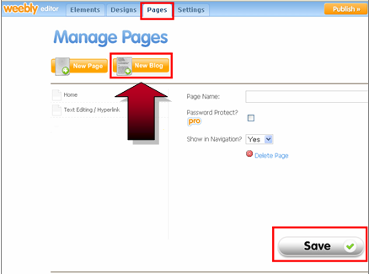

Click on "New Post" to Add Another Blog Post 11/28/2008
0 Comment(s)

This is my second blog post.
When I am done typing, I will click on the orange "Publish Live" button, and then just to be sure, I'll also click "Publish".
There is a space under each blog for others to leave comments.
So, has this tutorial been useful to you?
How's your website coming?

First Post! 08/21/2008
3 Comment(s)

Start blogging by creating a new post. You can edit or delete me by clicking under the comments.
You can also customize your sidebar by dragging in Elements from the top left "Blog Sidebar" menu choice.
OMG! Like, I can't believe this actually worked! Like, whoo-hoo!
When you are through typing, click "Save to Live" and then PUBLISH.

Have Users Send Your Blog URL to Twitter
I'm going to have to assume you know what Twitter is, and already have a Twitter account. If you don't, you should: www.Twitter.com
Below I'll show you the steps to insert some Custom HTML code on your page. Users will click on the code and magically send a message straight to Twitter! The message will be a link back to your Blog (or website, if you prefer).
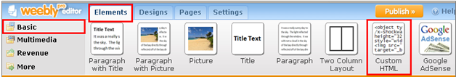
Begin by going to the Basic - Elements tab. Find the Custom HTML icon.
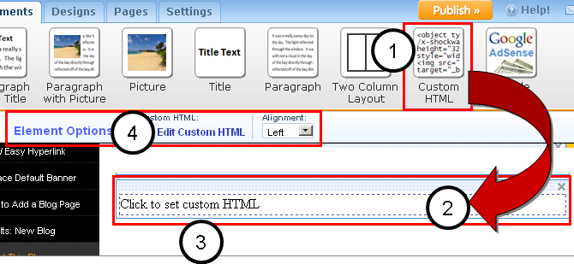
1.) Click on "Custom HTML"
2.) Drag-and-Drop the icon own into the work area.
3.) Click on the words: "Click to set custom HTML"
4.) Work bar appears in upper left area of screen. Click on the words: "Edit Custom HTML"
5.) The words in the work area will now have a blue background, indicating that you can edit them, or paste code on top of them. (NOTE:Be sure to edit the sample code to display your OWN URL.)
6.) Click anywhere outside the Custom HTML code, and you should just see the words: (Tweet This Post)
7.) Publish the website, then test the link. It should send a message to Twitter.
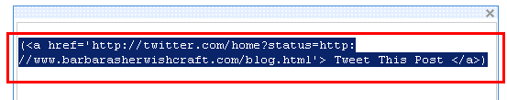
( Tweet This Post )
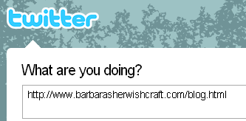

Click-and-drag 'Contact Form' to work area
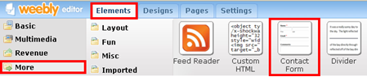

Edit 'Contact Form' Title, then Publish.
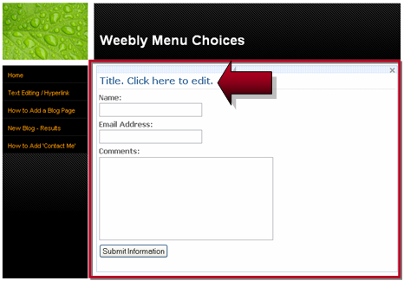

Results: Here is a Real Live "Contact Me" Form

Name:
Email Address:
Comments:

Neat Trick: How to See More on your Screen: "F11"

Before Hitting "F11"
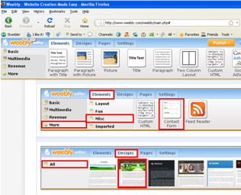
Sometimes when you're working in Weebly, parts of your screen seem to disappear. This can be irritating .
The solution is simple: Hit the "F11" button on your keyboard, and you will have more working space, and be able to see more of the screen.
When you're ready to go back to 'normal' - say, to navigate - just hit the "F11" button again. Everything reappears!
BTW, this works whenever you're on the web -- not just with Weebly.

After Hitting "F11"
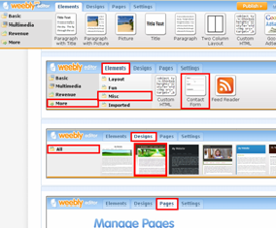

Weebly Help Shortcut
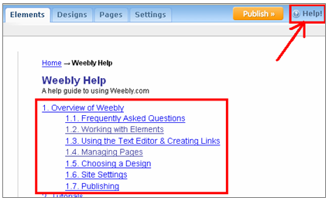

All information for this handout was taken from http://www.weeblytutorial.com/

