To start Tracking Changes:
- Click Review Tab on the Ribbon
- Click Track Changes
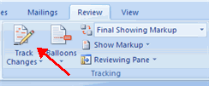
Document Views:
There are four ways to view a document after you have tracked changes:
- Final Showing Markup: This shows the document with the changes displayed
- Final: This shows the changed document, without the changes displayed
- Original Showing Markup: The original document with the changes displayed
- Original: The original document without any changes.
To change the view, click the appropriate choice in the Tracking Group of the Review Tab on the Ribbon.
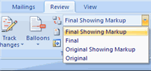
The Show Markup feature allows you to view different items (comments, formatting, etc.) and choose to view different authors’ comments.
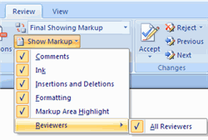
Accept or Reject Changes
When you view the changes in a document you can either choose to accept or reject the changes. This allows you to review the document by each change to accept or reject each change.
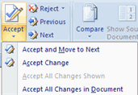
Inserting Comment Balloons
The New Comments icon also lets you add comments to the document.
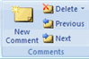
- Click next to the text you wish to comment on. Hold the mouse button down and drag your mouse to select the text.
- Click "New Comment." Type your comment in the balloon.

Deleting Balloons
- Locate the balloon you wish to delete.
- Right click the balloon.
- Click "Delete Comment" if it is a comment balloon. Select to reject the change if it is a revision balloon.

