Go to <http://www.studystack.com>

Go to the upper right hand of the Home page and login or create a new account.

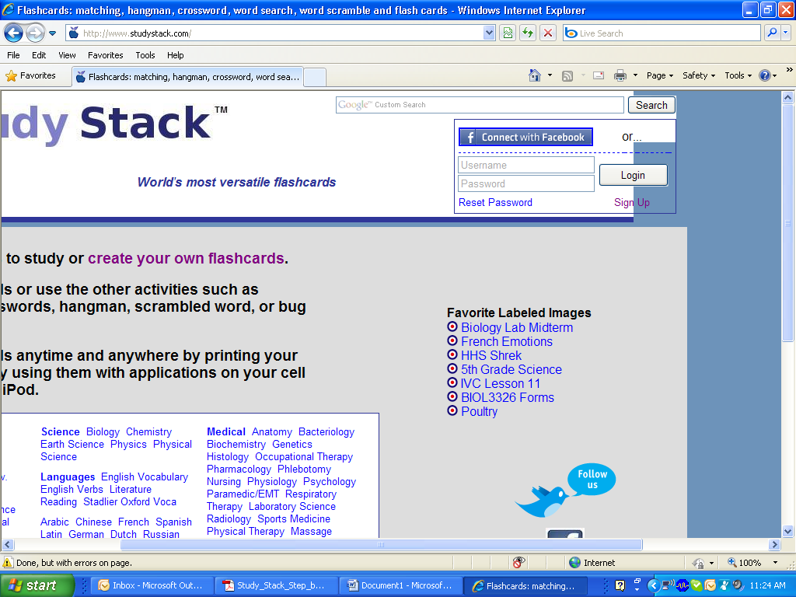

To create an account, when you click Sign Up, you will see the following screen.

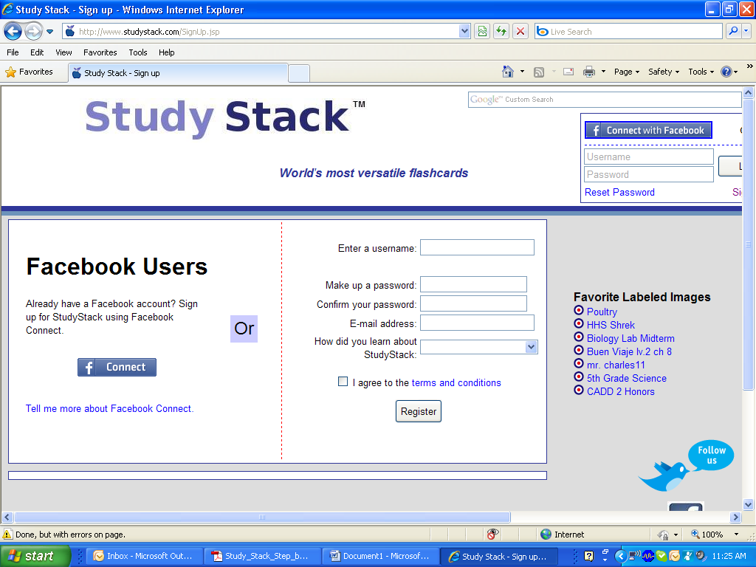

Once you have registered. Go back to the home screen and log in.

Click Crete new stack, it is found in two places. Click either.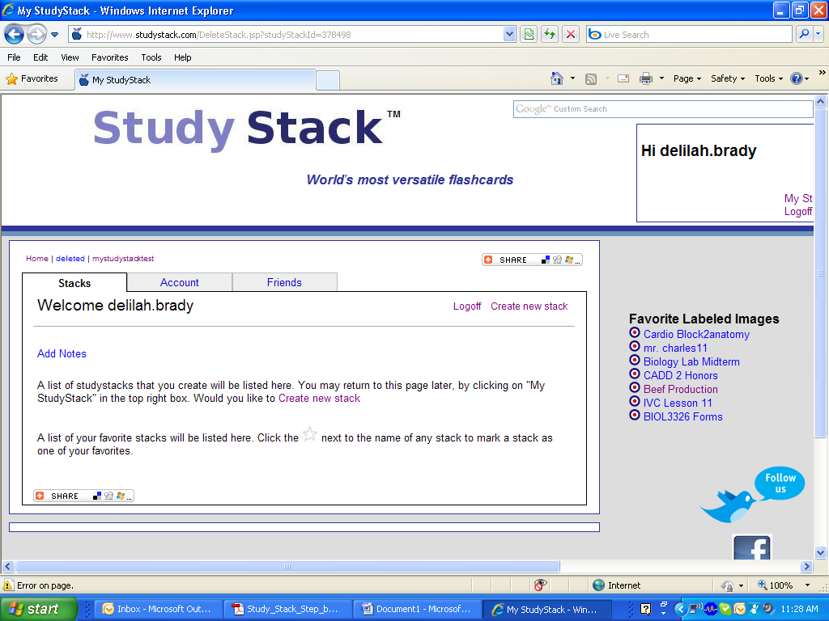

1. Creat a name for your stack. 2. Provide a description. 3. Choose a category from the drop down window. 4. Check the box next to “Prevent other users from modifying data” to prevent changes to your stack. 5. Check the last box to have Study Stack generate randomfill-in-the-blank clues for activities. 6. Save Changes.

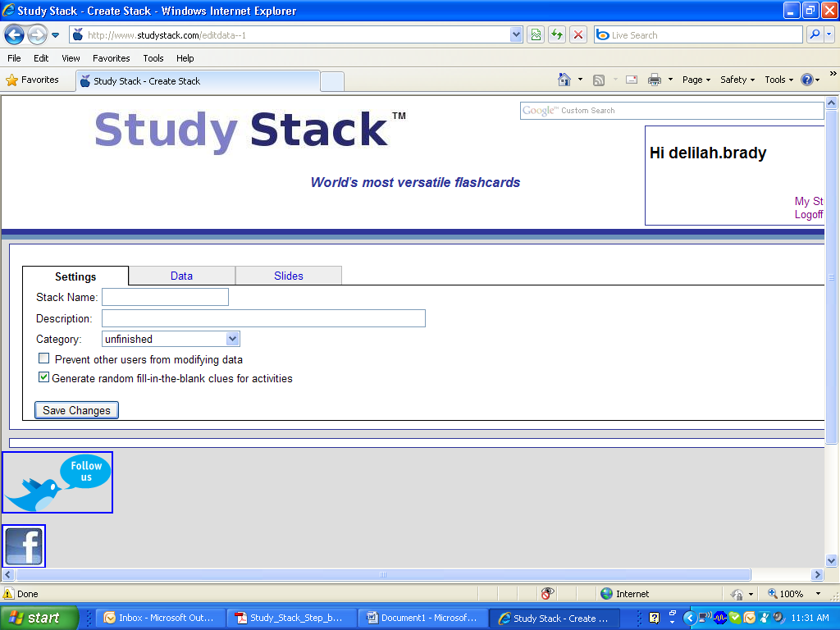

Next choose the Data tab

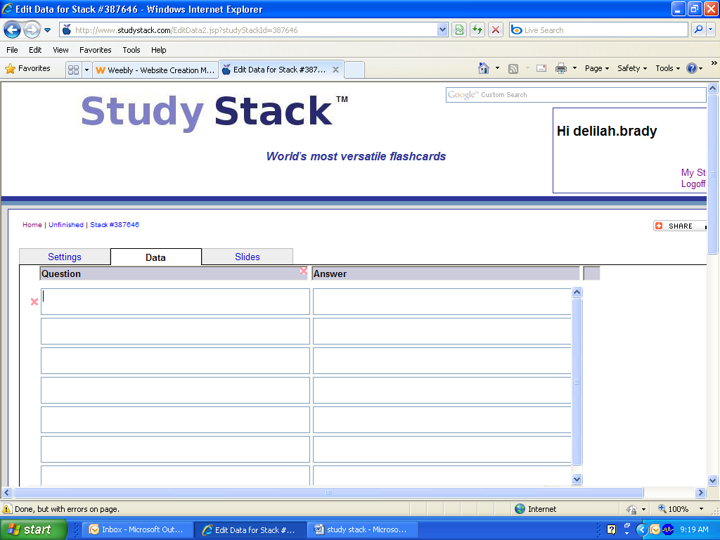

Enter your question in the Question column. Enter your answer in the Answer column.

Or you can import and existing list of questions

To Import questions and answers:

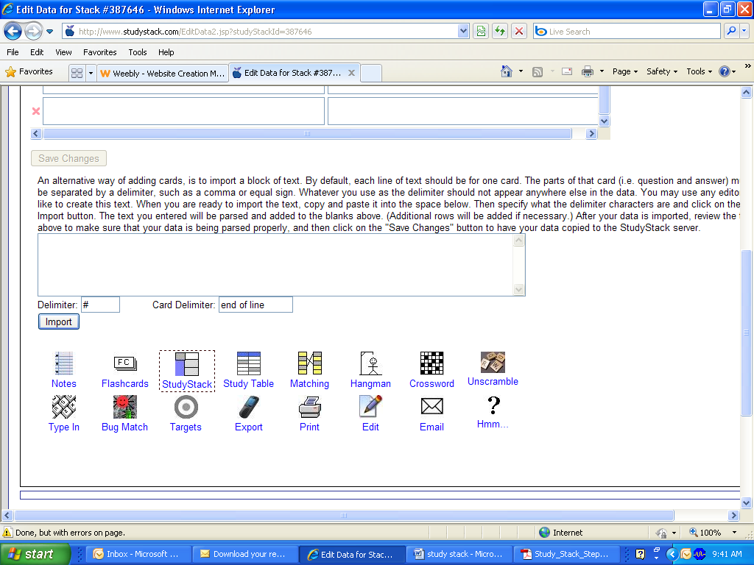

Each line of text should be for one card. The parts of that card (i.e. question and answer) must be separated by a delimiter, such as a comma or equal sign.

Whatever you use as the delimiter should not appear anywhere else in the data.

Copy and paste the list. Specify what the delimiter is and click Import.

Optional: Creating slide for Targets.

Click the Slide tab.

Browse for your image. Once you find it. Select Add Image.

You can resize image and add additional images as needed.

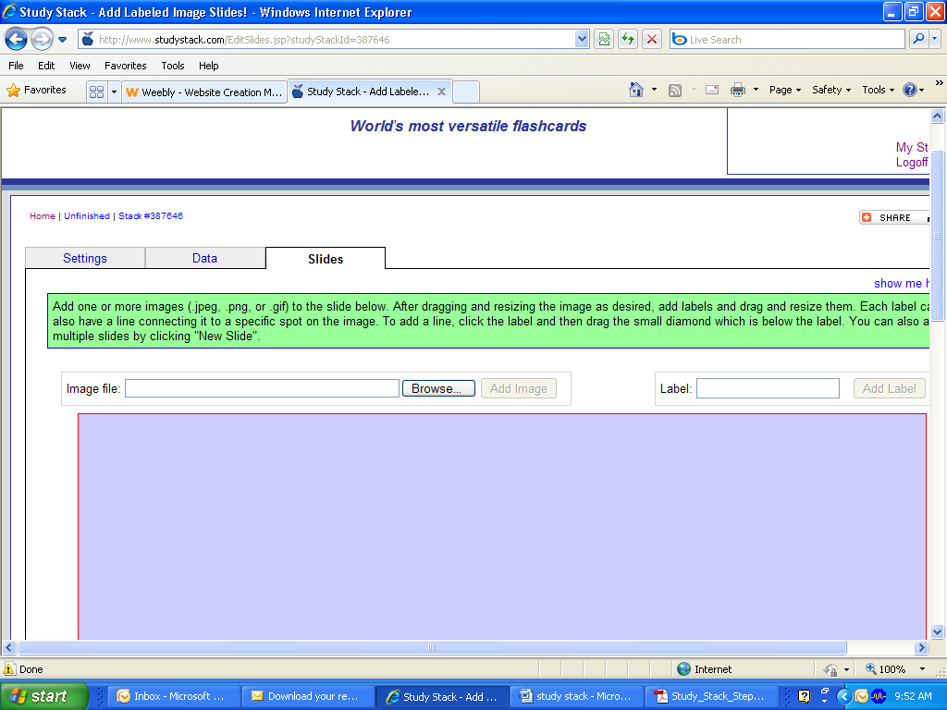

Next, add labels to your image. This will create quizzes to identify the parts of your image. Type in the label and add label.



The label can be resized and placed on the image. The background color and font size can be changed. This will become a target.

Save changes.

Your are finished!!

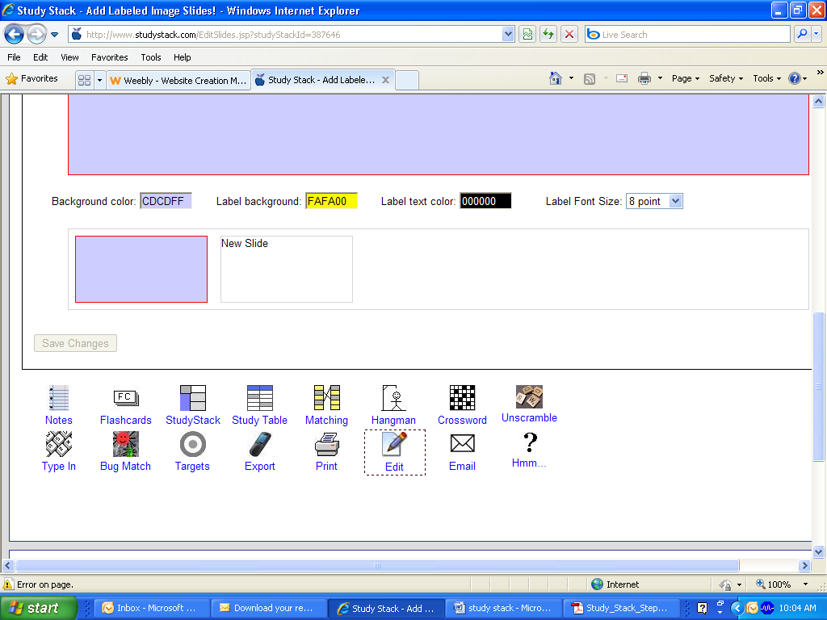

You can browse your Study Stack and share it with your class….

To return to your account and see your stacks, go to the upper right hand of any page and click on My Study Stacks. This will take you to a list of your stacks, which you can create new stacks, edit or delete old stacks.

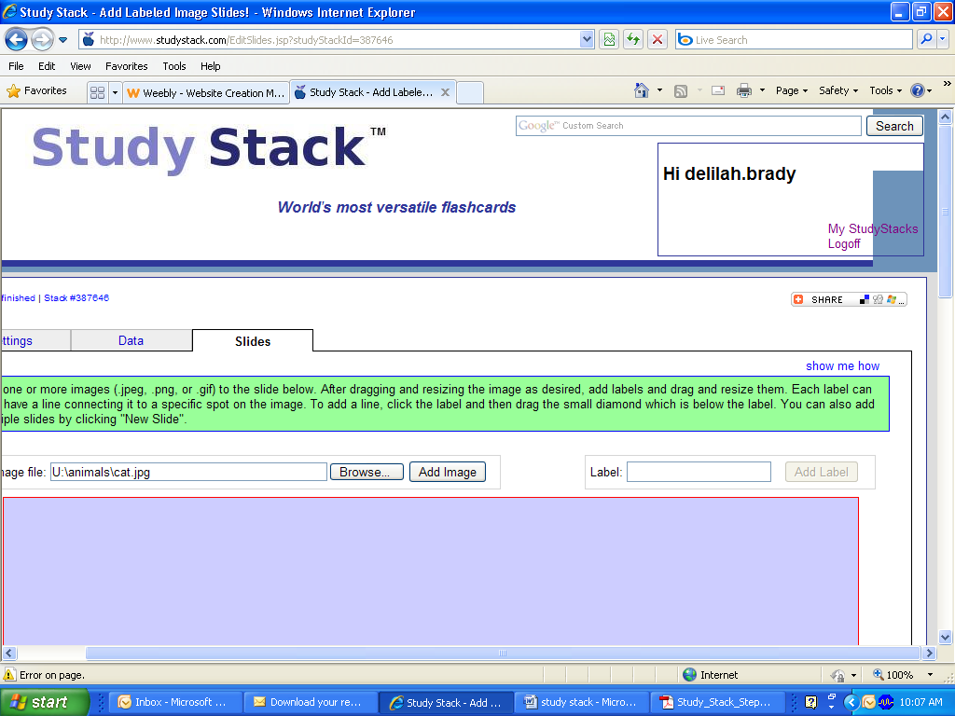

To share with your students, just copy the URL for the study stak and give it to your students.

