You can download skype to your home computer by going to www.skype.com/download
Double click Skype icon on your desktop:

If you are new to Skype:

Click link

Don’t have a Skype Name

Fill out the required fields, take the check out of the box if you don’t want skype to send you promotional emails. Click I agree-create account
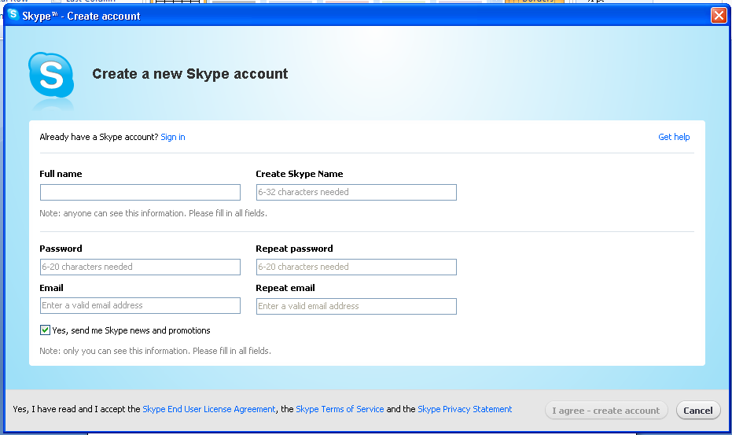
At the Welcome to Skype screen:

Type in your Skype Name/Password

SKYPING FOR THE FIRST TIME

Under contacts you should see Echo/Sound Test Service
That is an automated testing service that helps you make sure
your microphone and speakers (internal or external) or headset
are working.
Highlight (click one time) Echo/Sound Test Service
On the right you will see a green call button. Click call.

A recording will prompt you to say a word or two. Your
message then will be played back to you. If you hear your voice
played back, everything is working.

MAKE THE CALL

To call someone, first you need to find them in Skype. Click New, then Click New Contact,

Type in the skype name, full name or email address. Click Find.

After you find that person’s profile, highlight the name and click Add Contact.

Once you have added the to your contact list. Highlight the person’s name.

On the right you have options to call or make a video call. Press the green button for your option. You will hear a dial tone. If the call recipient is online and able to take your call, he or she will greet you. Speak at normal volume; you’ll be surprised at the clarity of the sound.

When done, click the red hang-up button.

If you don’t have a web cam:

You can still use skype to instant message. Click on your contacts name.

On the bottom right, type your message in the box and hit enter.

CAN’T GO TO THE PHONE?
Just as you turn off your cell phone while teaching, you’ll want to let others know when you can and can’t take Skype calls.

Ατ τηε τοπ λεφτ, χλιχκ ον Σκψπε, Γο δοων το Ονλινε Στατυσ

Start Small

To reduce the chance of problems, start small and be sure to practice
several times at home and at school without students present. Even
just Skyping to a class down the hall or across town to a friend’s
classroom is fun at first and will build your confidence level. Also, the
first time students are exposed to any tech tool, their excitement often
turns to silliness, so be sure to practice before initiating a serious
project with Skype.

Sending Files:

Skype allows you to send large files to friends or colleagues. Use Skype to exchange photos, drawings, documents, and more. Drag the file to the contacts’ name.

Reminders:

As with any telecollaboration, keep in mind that time zones and
school calendars differ greatly. Setting up guidelines for discussions
also is a good idea. Content that is appropriate for a class at one
school might not be considered appropriate in another culture.
Honest and polite discussions between teachers beforehand can help
prevent problems.

TIPS AND TRICKS
Skype also allows you to click the Live tab to see and/or join public
conversations at any time. A number of security and safety issues
prevent that from being a good classroom choice, but after school
you might find a lively discussion by and for teachers.

Advanced users can add the Skype RSS feed to their aggregator to
stay current on the latest from Skype. You also can add a “Call me”
button on your Web site.

Skype users share ideas for using Skype in the site’s Forums section.
Take a look there or post your own message to find answers to your
Skype questions.

Adding a WeeMee avatar:

Finally, you’ll probably notice that most users have either their photo
or an avatar (a personalized cartoon-like figure) in their contact
profile

http://skype.weeworld.com/weemee.aspx

