http://www.sascurriculumpathways.com/
Click subscriber login in the upper right corner.
1st time: use the school’s user name and password (will be given to you) to create your personal account.

Log in to your SAS Curriculum using your new created account.
You will be taken to the home page.  If you need to get back to this page, click the SAS Curriculum link in the upper left corner of the site. | 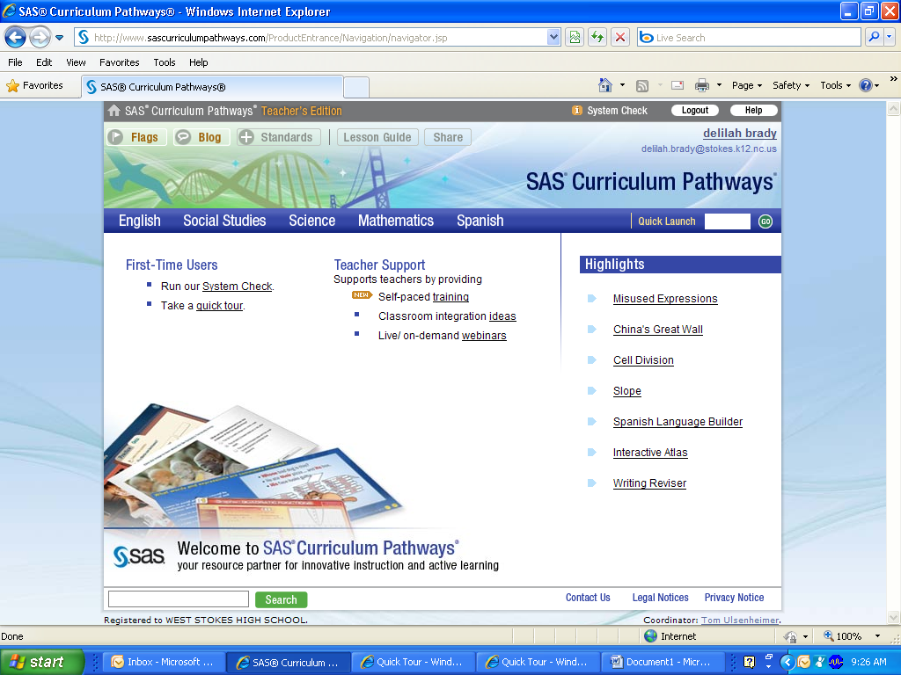

Select one of the 5 subjects

Each subject is divided into categories which relate to the standard course of study.

Select a category from the drop down menu

Select a topic. There are 5-10 topics in each category.

At a Glance:
List resources available on a topic

Different type of resources are provided

Click a title to view a resource

InterActivity:

Students explore, apply, and analyze content thru multimedia and online tools

To select another resource or topic, click on the navigation trail or click the back button.

Web Inquiry:

A guided, self-paced investigation, organized around a Focus Question.

Students answer the question in a three step process:
Read, Research, Respond.

Audio Inquiry:

A short tutorial that answers a question. Images and text help students recall information.

Students must complete the quiz with 100%.

Classroom Activity:

Promotes student dialogue or hands on learning.

Web Lesson:

Integrates internet sites into the learning process by using handouts, web sites, and step-by-step instructions

Project:

Offers students directed activity.

SAS select, annotate, and maintain internet sites to support teaching and learning

Quick Launch:

Every resource has a quick launch number.

It is referenced on the navigation trail or the At a Glance page.

Enter the Quick Launch number to go directly to a resource.

Use the search box in the bottom left corner to quickly locate resources on a subject.

To search a phrase, put “quotes” around the words.

The teacher edition has extra features:
Flags: used to bookmark a resource and add notes.
Blog: allows teachers to discuss classroom experiences using SAS. Post can be viewed by any registered teacher.
Standards: helps navigate according to state standards.

Flags/Blog/Standards Icons

When viewing a lesson or activity, Flags, Blog and the Standards may appear with an orange icon.

For Flags and Blogs, the icon indicates that an entry about the resource exists.

For Standards, it indicates specific standards that align to the resource are available.

Lesson Guide:

Offers learning objectives, assessment criteria and/or answer sheets, and instructional suggestions.

Share:

Assign: provides students directions to a resource. The students’ user name and the quick launch number are also available.

Recommend: allows you to share a resource and information on a free subscription.

Student Version:  When students log in to SAS Curriculum Pathways, the teacher function is omitted, but the resources and navigation are identical. | 