**Open word as a new document or open a document you already created.**

**Opening the Mail Merge Sidebar Wizard**

If you are using **Word 2003**, open your letter in Word and then bring up the Mail Merge

Sidebar Wizard by going to Tools > Letters and Mailings > Mail Merge.

If you are using **Word 2007**, click on the Mailings Tab on the Ribbon then click on

Start Mail Merge and select Step by Step Mail Merge Wizard.

|  |  |
| --- | --- |
| **Step 1**  The sidebar to the right will appear on the right side of the window, next to your document.  For this example, since we are working on labels, put a check in the option ‘Labels’ and click on ‘Next: Starting document’ at  the bottom of the sidebar. |  |

|  |  |
| --- | --- |
| **Step 2**  Keep the Check in the Change document layout  Click Label options |  |

|  |  |
| --- | --- |
| The Label Options box will pop up.  Select by drop down the Label Vendor: Most labels will be under the Avery US Letter.  Once you have selected the vendor, select Product number. The product number will be found on the container the label came in.  Click Ok. |  |

If you would like to see the boarders of the labels, Click Page Layout, Page Borders

The Borders and Shading options box will pop up, select the Borders Tab, Then Select the All option.

Click ok. (Make sure you reverse, take borders off, this before you print)

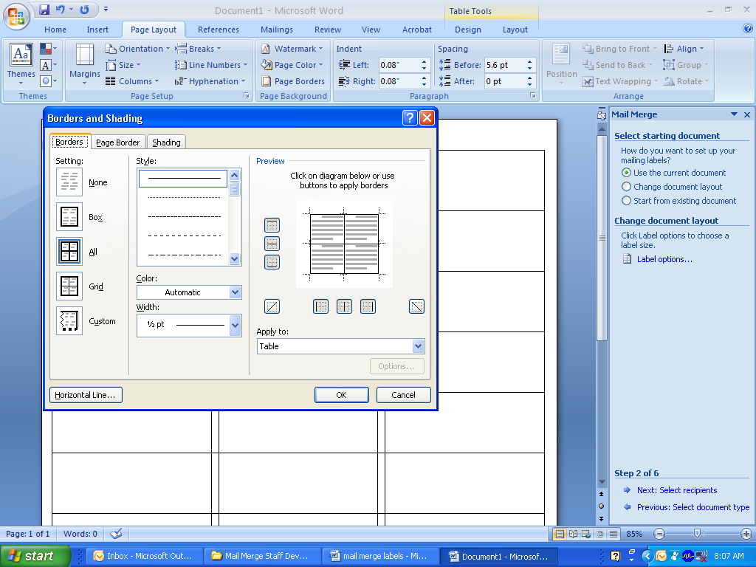

|  |  |
| --- | --- |
| Once you have selected the label options, and borders, Click ‘Next: Select recipients’ |  |

|  |  |
| --- | --- |
| **Step 3**  This is the step in which the data source is linked into the Word document.  As you can see there are three options for this: ‘Use an existing source’, ‘Select from Outlook contacts’, and ‘Type a new list’.  Caution against using the ‘Type a new list’ option as the list it creates can often be difficult to manage.  To use the Outlook contacts, you must already be using a Microsoft Outlook address book, so if you do not already  use Outlook for your e-mail, then this option will not work for you.  This leaves the first option, using an existing list. This is we entered the data we wanted to use into a spreadsheet before we started the mail merge process.  In order to tell Word where the data source is, click ‘Browse.’ |  |

|  |  |
| --- | --- |
| Navigate to the folder where your data source is located and double click on its name to select it. |  |

|  |  |
| --- | --- |
| Because there can be several worksheets on the spreadsheet that you select, the following window pops up, prompting you to select one.  If you have column names in the first row of your spreadsheet, make  sure that the ‘First row of data contains column headers’ box is checked.  Clicking OK. |  |

After selecting the tab that has the data source, another window pops up to confirm the

mail merge recipients.

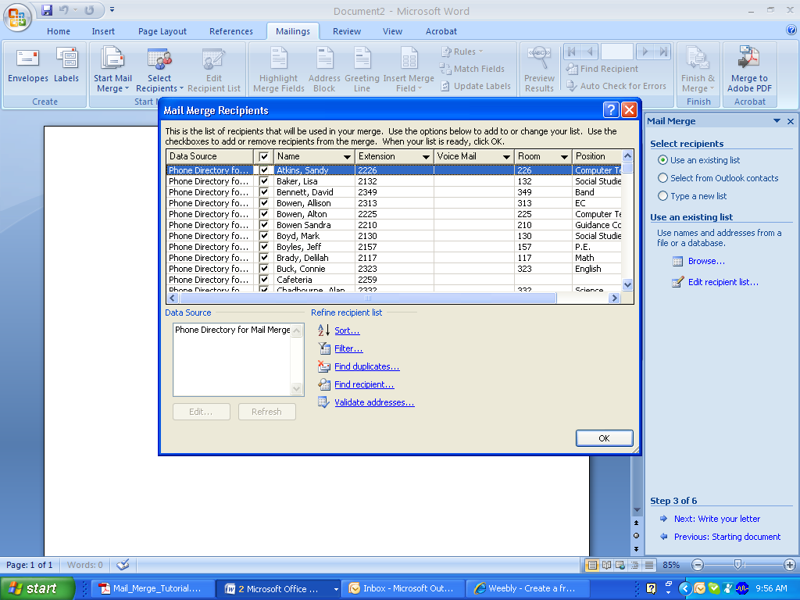

If there is someone on the list that you know you do not want to receive the label, then you can uncheck the box next to that person's row. For this case, we want all of the recipients to receive the label, so just click the ‘OK’ button.

Click Next: Arrange your labels.

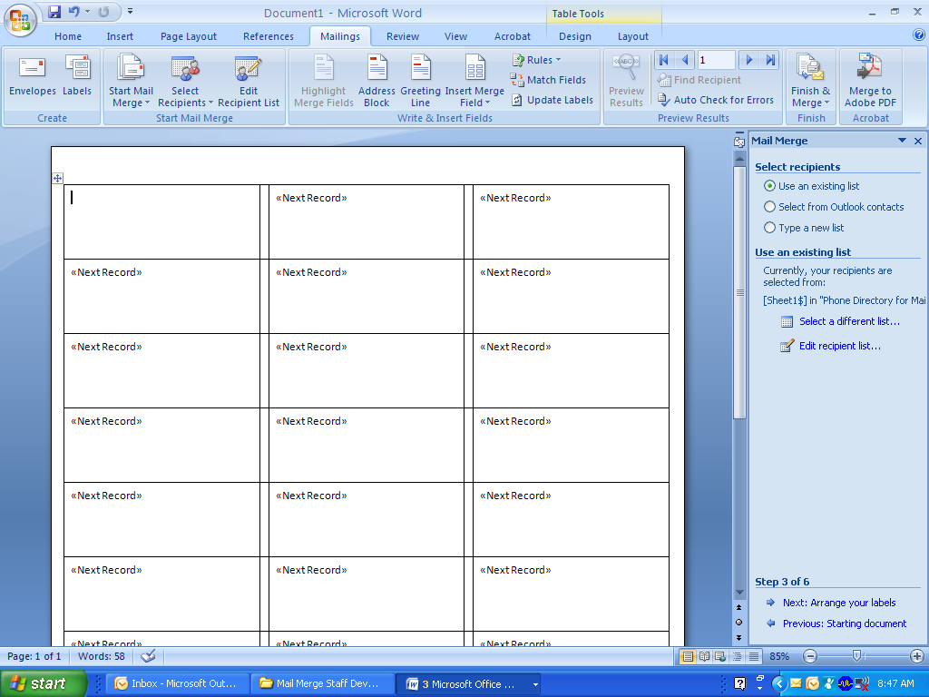

|  |  |
| --- | --- |
| **Step 4**  Inserting recipient information from the data source into the Word document. There are a number of different options for types of items to insert. If you pick any of the first four options, then Word will match the fields that you have in your data source to what it believes are the corresponding fields that it has for the items. This is called “mapping.”  However, I have found that Word does not always get the mapping correct.  Therefore, Use the ‘More items’ option. This gives you more control over where and how the fields from your data source are inserted. |  |
| First select the place in the document where you want to insert a field from the data source and click on ‘More items’.  A box will pop-up, giving you a list of all of the fields that are possible to insert. (Remember how in Step 3 we told Word that the headers were in our top row? This is why.)  Select the field that you want to insert and click ‘Insert’. It will replace the selected section of text with “«field_name».” |  |

|  |  |
| --- | --- |
| Note the spacing around the fields. Word will merge in the data exactly where the  fields are placed. So, if you want a space between someone’s «First_Name» and  «Last_Name», you have to make sure that is there in your document.  Once you have entered all of your merged fields into the correct places and checked the formatting around them,  Click Update all labels.  If you are satisfied with the look of the label:  Click ‘Next: Preview your letters’. |  |

|  |  |
| --- | --- |
| **Step 5**  At this step you are able to preview your letters to make sure that everything will look correct once the records from the data source are merged.  You can check different recipients’ letters by using the arrows, look for a specific record by searching the merge fields, or even ‘exclude’ one from the merge.  At this step check at least 4 or 5 recipients (depending on the size of your list) to make sure that all of the merge fields look right.  After spot-checking a couple of records, click ‘Next: Complete the merge’. |  |
| **Step 6**  Once you are happy with the way that your merge is set up, it is time to complete it.  You can choose to either print the letters or view the merge as individual letters.  Either option will bring up the box below. |  |

|  |  |
| --- | --- |
| You can choose to merge all of the records in the data source, just the  ‘Current record’ that you are displaying in the preview, or a certain section of continuous records.  Click OK |  |

If you are selecting a certain selection of records from an Excel document, remember that the first row is the Merge field names. Therefore, if you want just rows 3-

7 in Excel, you need to type in “2 to 6.”

By selecting ‘Print’, Word will send your merge directly to your printer. Each letter it

prints out will have a new recipient’s set of data populating the merge fields (as it looks

in the preview step). Only choose this step if you are 110% sure that everything is

exactly how you want it.

Selecting ‘Edit individual letters’ will open up a new Word document (usually called

“Labels 1”). In this document, each page will contain the form letter with one of the

records merged into it. You can then edit individual letters if you want to, for example if

you want to add a message to a specific recipient. It’s also a good way to do a final

check that everything is correct before printing. From this new document, you can just print as normal. Sometimes there will be a third option: ‘Merge to email’. This option is only available if you are using a Microsoft email program, such as Outlook, and if you have "e-mail address" as one of your data fields. And that’s it.

You have now created a label merge!!