Go to www.kwiksurveys.com
Click signup in the upper right corner
Once you have signed up, you will receive a confirmation email.
Log in to www.kwiksurveys.com
New Survey
To create a new survey click the button

- Open / Close Survey
  - Start and stop survey response collection.
- Start and finish dates
  - Start and end date of survey collection.
  - Time zone for above dates
- Survey completion action
  - Show a message on survey completion
  - Redirect to a URL on completion
  - Display survey results
- Display progress bar
- Switch question numbering on / off
- Randomize question order on each page
- Numbering of presentation question on/off
- Disable surveys back back button on multiple page surveys
- Receive completed surveys by email
- Block participants from taking surveys more than once
- Change the surveys button text
- Password protect survey
- Password protect surveys public results
Allows you to change the following:
- Survey colors: B&W Print(Ideal for printing in Black and White printers on color printers), Ice Blue, Default, Stone, Sky Blue, Citrus, Spring, Blue – Grey, Passion Fruit, Peach – Pastel, Spring onion, Olive, Sand, Vista, Ocean Green, Brick
- Background image: A background image which meets the following criteria may be uploaded:
- Size:
  - Maximum of 250Kb
- Format:
  - gif
  - pjpeg
  - jpeg
  - png
  - bmp
  - x-png
The background image is tiled to cover the whole screen.

Uploading the background image
The image can be added by clicking the choose file button. Once your file has been chosen click the save button, this will upload the background image and close the style window.

Clearing the background image
The background image can be cleared by clicking the 'Clear background' button. This will clear the background and close the style window.

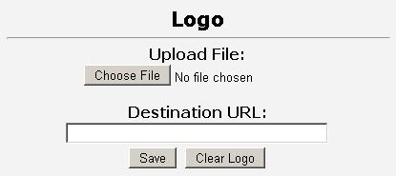

A logo which meets the following criteria may be uploaded:
- Size:
  - Maximum of 50Kb
- Format:
  - gif
  - pjpeg
  - jpeg
  - png
  - bmp
  - x-png
The logo will appear in the upper right next to the survey title.
When the logo is clicked it will forward you to a new URL. The default URL is KwikSurveys home page.
Uploading the logo
The logo can be added by clicking the 'Choose File' button. Once your file has been chosen click the 'Save' button, this will upload the logo and close the logo window.
Clearing the logo
The logo can be cleared by clicking the 'Clear logo' button. This will clear the logo and close the window.
Destination URL
Here you may enter a URL to be directed to when the participant clicks the logo.
Do not forget to include http:// in you URL otherwise your redirect will not work!

Each survey may have its own title and a description that will be shown at the start of the survey.

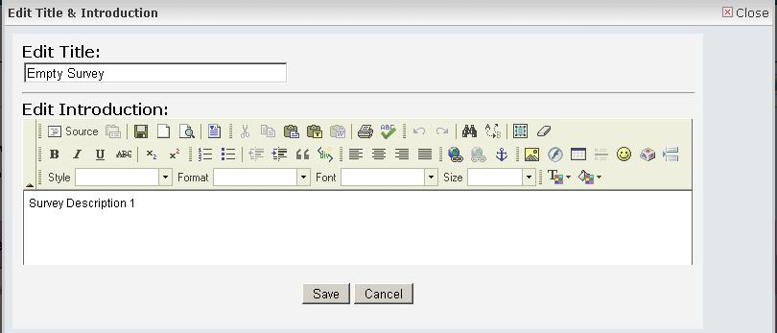
Text and images may be entered into the description field.
The Results Overview displays a summary of the surveys responses.
A response count is shown at the top left of the screen.

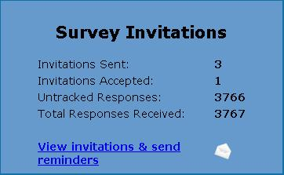
View invitations and send reminders
This function takes you to the email centre where you may view email invites and send reminders by clicking the send emails button then selecting the survey and email list you wish to send reminders to.
Invitations Sent, Number of emails sent using the Email Center, Invitations Accepted, Number of tracked responses from Email Center, Untracked Responses, Responses from untracked web link, Total Responses Received, Total quantity of responses received

Example results
Within the Results Overview there are the following operations:
- Expand
  - A summary of text answers are shown, this shows all text answers in the summary screen.
- Pop up
  - The pop up button opens the question in a new window with all answers shown.
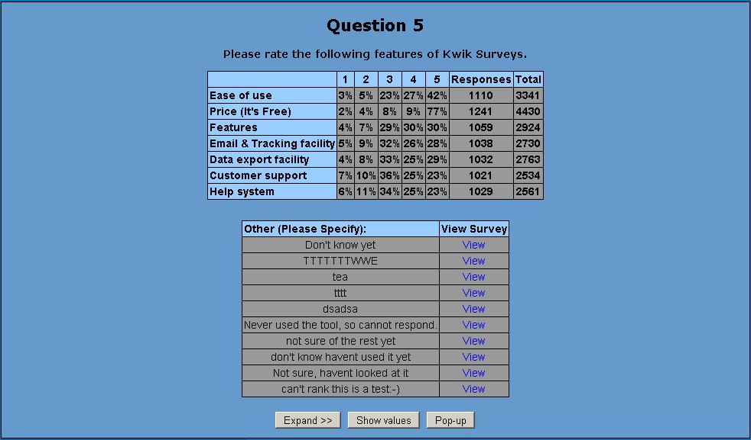

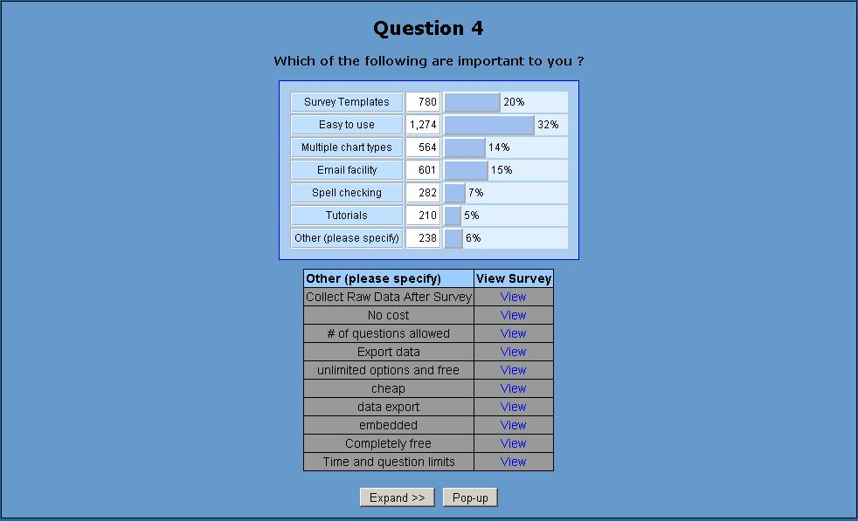

The following operations are available in results overview: Print, Export, Individual Results, Results Filtering, View Invites & Send Reminders

Launch
The Survey Launch area allows you to distribute your survey. You may produce a link or email your survey using the Email Center.

The following options are available:
- Create Link
- Email Center

Create Link

A website link is the easiest way for you to collect responses. Simply paste the code into a web page or email and your responses will be collected.

For your convenience Kwik Surveys provides several types of links.
- Website Link
  - This is a HTML link that you can paste directly into your website or blog
- Regular Link
  - A regular link requires the participant to copy and paste the link into the browser.
- Mini Link
  - This is a shortened version of a regular link
- Secure Link
  - This is a HTTPS sercure version of the mini link
- Website Results Link
  - This is a direct HTML link to your surveys results
- Regular Results Link
  - Direct link to survey results. Requires the participant to copy and paste the link into the browser.
- Embedded Survey Code
  - This displays your survey within a web page and uses HTML I Frames.
- Survey in new window
  - When this HTML link is clicked it opens a new window.
- Popup request window
  - The pop-up survey uses JavaScript to open a window inviting your participant to take part in the survey.
Do not change the generated link code otherwise your surveys may not continue to work

Preview

The Preview function allows you to preview how your completed survey will look.
All answers entered are stored and can be seen in Results Overview.

Page Options

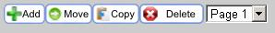

The following functions are available in the page options: Add Page, Move Page, Copy Page, Delete Page, Select Page

Add Page
The add page function allows you to add a new empty page to your survey. You can add an empty page either before or after the current page. | 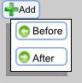

Move Page
The following functions are available to move pages:  - Before: This will shift the current page left and swap it with the previous page. This has no effect on the first page of the survey.  - After: This will shift the current page right and swap it with the next page. This has no effect on the last page of the survey or surveys with 1 page.  - Select | 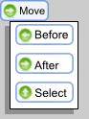

You can chose to move the page to any place in the current survey. You must chose to place it before / after the destination page. | 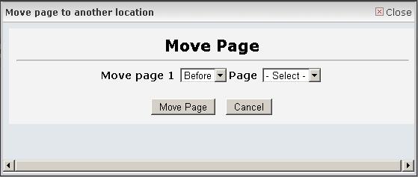

The copy page facility duplicates the current page with all questions by creating a new page.  The following copying functions are available:  - Before: This will copy the current page left / before the current page.  - After: This will copy the current page right / after the current page.  - Select | 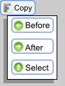
You can chose to copy the page to any place in the current survey. You must chose where to copy it.

This deletes the current page. A confirmation message asks you to confirm page deletion.
Once a page has been deleted it is impossible to recover it.

Select Page

The page selector allows you to jump directly to any page in the survey.
Add Questions:
Click add question button
Type your survey question in the space where it reads Sample question text.

click options button

Select question type from the drop down menu:

Multiple Choice – Single Answer:
Example question with standard layout

Example with drop down menu layout
Example with horizontal button layout
Example with additional comment field

Multiple Choice – Multiple Answers:
Example question with standard layout
Example question with 2 column layout
Example question with horizontal layout and additional comment field
Star Rating:
Example question with 5 stars
Example question with a comment field

True – False:
Example question

Yes – No
Example question

Single Text Box:
Example question with multiple lines of text
Example question with a single line of text
Example question where you can only enter numbers
Example question with Email address validation

Matrix of Choices – Single Answer:
Example matrix question

Matrix of Choices – Multiple Answers:
Example multiple choice matrix question with a comment field

Multiple Text Boxes:
Example multiple text boxes

Pictures and Text:
Example picture and text.
Ordered List/Ranking question:
Example ordered list / Ranking question

After you have entered your question, click the preview button to see the what it looks like, you can make changes before you save it.

Once you are satisfied with the way your question looks, click save & exit.

