Hippocampus
http://www.hippocampus.org/
- You can browse an alphabetical or sequential list of course topics.
- You can find course topics that relate to particular pages in commonly used textbooks.
- You view complete courses including assignments, activities and assessments.
Select a subject on the left side

Once you select your subject on the left, you will notice Course selection tab and Textbook tab under the Browse section.
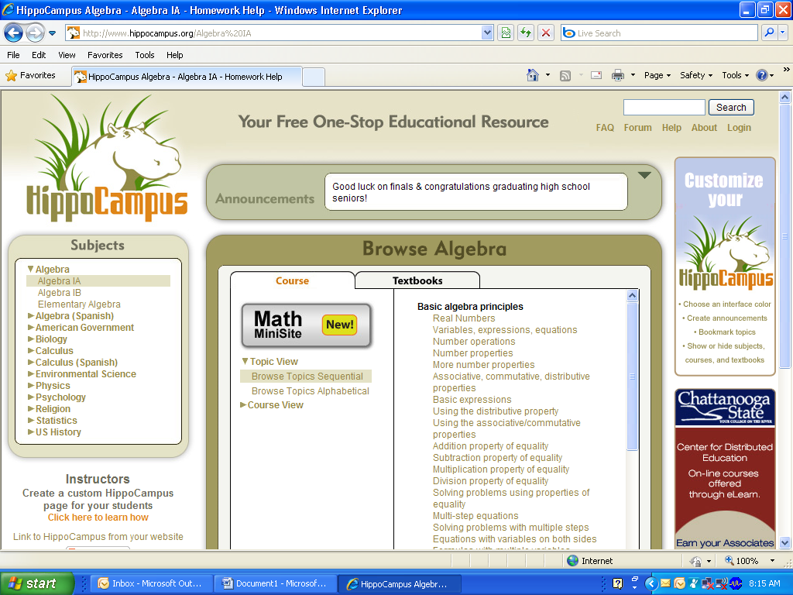
Each tab is divided into two panels. The left panel contains a menu displaying the available choices and the right panel displays content associated with the selected choice.
Course tab - you can either browse a list of the multimedia topics or the complete table of contents of the selected course.

Textbooks tab - view the list of Textbooks that have been correlated to the course content. When you select a textbook, the right panel displays the titles of the course topics preceded by the page range that each topic corresponds to.
To launch a course topic click one of the topic titles in the right panel of the Browse block, the topic will open in a new window.
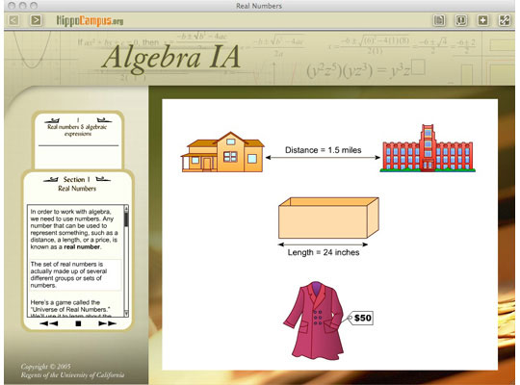
The frame above the topic content contains a number of buttons you can use to control the display of the topic content.
- Left Arrow and Right Arrow: Displays the previous or next course topic.
- Topic Text: Displays the narration text in a panel next to the topic content (if available). You can change the size of the panel by dragging the panel divider.
- Feedback: Allows you to send your comments, questions and bug reports to the HippoCampus staff.
- Share: Allows you to place a link to this topic at a number of popular bookmarking sites.
- Link: Displays the URL you can use to link directly to this topic.
You can create your own Instructor page that gives your students the exact place you want them to be.

Click the link under instructors that says, “Click here to learn how”

Choose a Login ID that is easy for you to remember. You will need to use it to access your custom page. You will also need to provide your Login ID to anyone with whom you would like to share your custom page with, like your students. You will not want to share your Password with anyone else since you will use your Password to edit the contents of your custom page.

Hippocampus will email you a confirmation email, including a link to your page. This link is the link your share with students.

Once you create your account, log into hippocampus
Click the hide buttons to hide all the subjects except the ones you teach. You can hide textbooks also.

