Google Docs – Forms – Flubaroo – Grading Assignments
Go to:  docs.google.com  sign in or create an account | 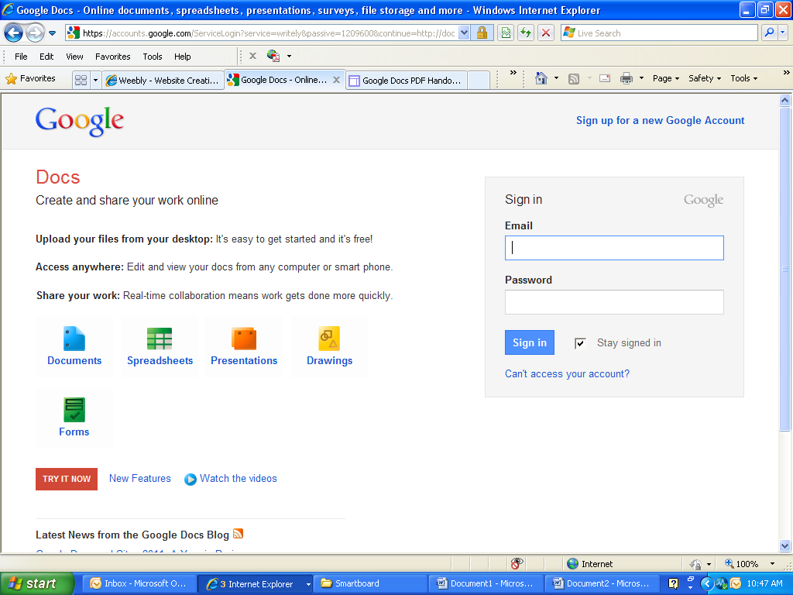
Go to http://www.flubaroo.com/

Click the “Try it now” button.
Click the link “this spreadsheet”. Make sure you are signed into your google account.
Before you can grade it, you'll first need to make your own copy.  Click file,  Make a copy | 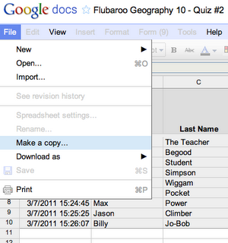
Click OK
Click Insert > Script | 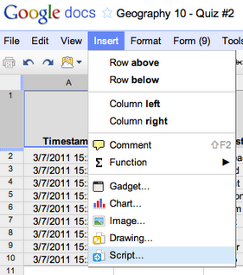
Click on the word Education  Scroll down to you see Flubaroo  Click the “install” button  Once it starts installing you will see it change to “installing” | 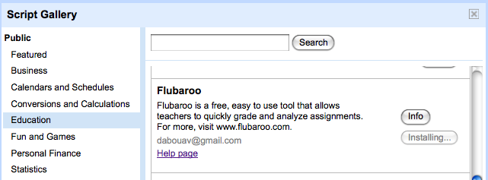
Once it has finished installing it will change to installed.

Click the X at the top of the box to exit the install.
Notice at the bottom of the spreadsheet, we are on the student submission sheet
After installation, you'll see a new menu in the spreadsheet called "Flubaroo" (it may take a few seconds to appear). Once you're ready to grade, just select "Grade Assignment" in this menu. | 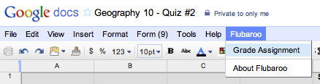
Click Ok if you get the authorization required screen. | 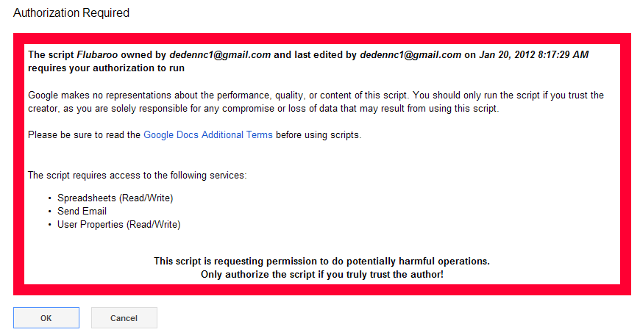
Flubaroo will ask you a few questions, such as:
- If any questions should not be graded.
- Which questions are for the purpose of student identification (e.g. name, student id, email).
- Which submission should be used as the answer key.
Grading Step 1:  Select the grading option for each question.  Options are:  1 point  2 points  3 points  4 points  5 points  Identifies Student  Skip Grading | 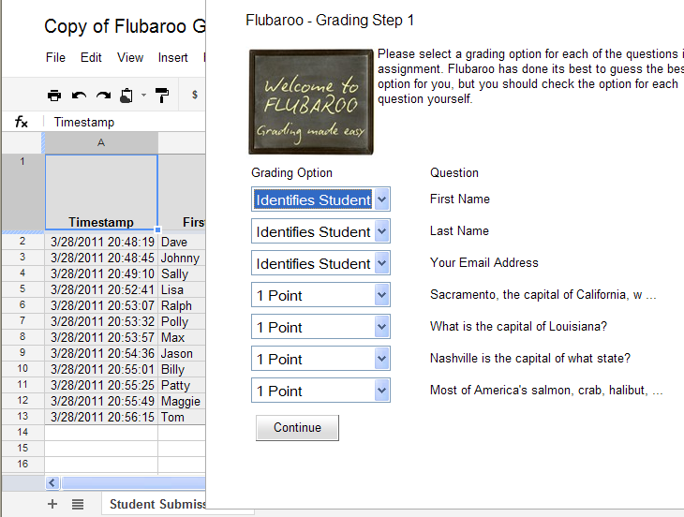
Grading Step 2:
Select which submission should be used as the Answer Key

Once you have clicked the selection, hit the enter key.
It will take a minute or two to grade your assignment.
Once it has completed the grading, to view grades: click the view grades button on click the x in the right corner.
Notice at the bottom of the spreadsheet there is a tab for grades now. | 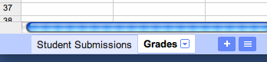
Click the Flubaroo tab it will give you the options to regrade, email, view report. | You might want to regrade the assignment if more students submitted answers, or if you want to throw out a question that most students got wrong.
Email Option: | If you choose to email each student their grade, you'll be given the option to include an answer key in the email. You can also include a short message to your students. The email sent to each student will include their total score, and their score for each question (with incorrect answers highlighted in red). Note: You will only be able to email students their grades if the original assignment had a question asking them for their email address.
Choosing "View Report" shows you a summary report of the grading. The report includes the distribution of grades (a histogram), and a button to email yourself a copy of the report. | 