Google Docs - Forms
Go to:  docs.google.com  sign in or create an account | 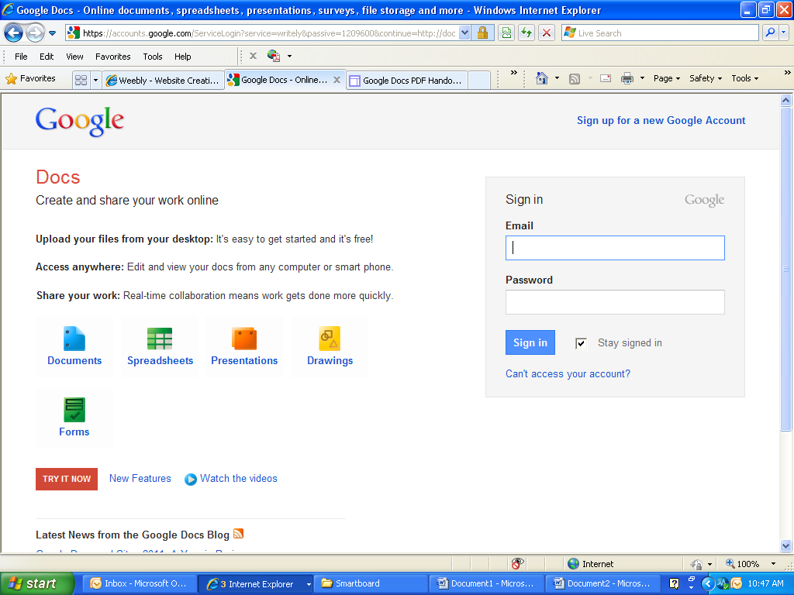
Opening page  Click Create button | 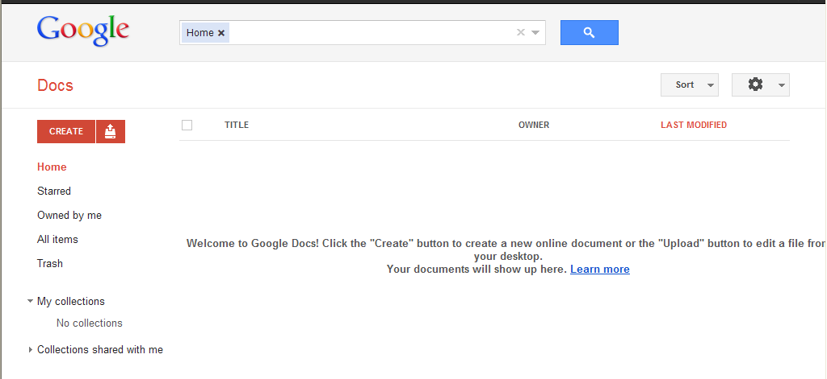
Select Form
Your untitled document will open in a new window | 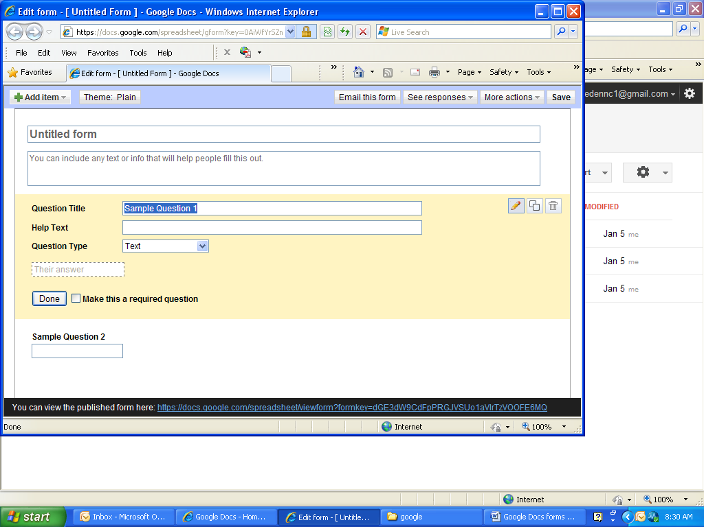
Add Items:
You can add a question for add item tab or as you are composing the question. Can edit section header, page break.
Email this form button: you can choose who to email this form.
See Responses:
Summary or spreadsheet
More Actions:
Embed or Edit Confirmation
Give your form a title, and include any text that will help people fill this out.
Begin entering questions:
To the right of each question, you can edit, duplicate, or trash
Types of questions:
Text
Paragraph text
Multiple Choice
Checkboxes
Choose from a list
Scale
Grid
Put a check in the box to make this a required question. Click Done button when finished with the question and ready to start the next question.
Google forms saves while you are working on it. It never hurts to hit the Save button.
At the bottom of the browser, it will give you a link to the finished product.
When you are back at your home screen you will see the form you created. Click on it to open
It will open in a spreadsheet view.
To edit your form click on the form tab and select Edit form.

