Google Docs - Document
Go to:  docs.google.com  sign in or create an account | 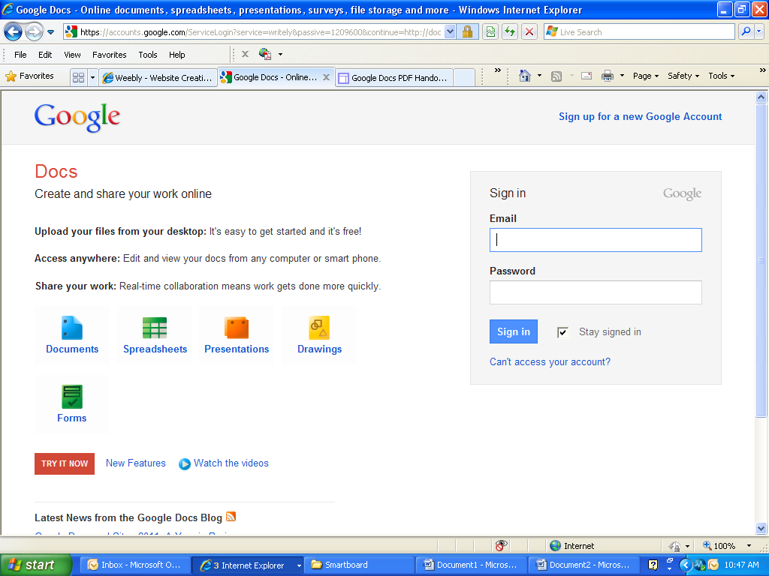
Opening page  Click Create button | 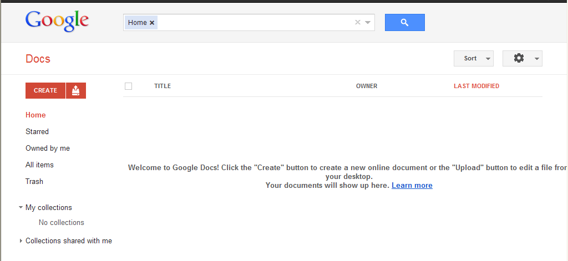
Select Document
Your untitled document will open in a new window
Icons across the top bar
Print, undo, redo, clipboard, paint format, font style, font, font size, bold, italics, underline, text color, text background color, insert links, insert pictures, numbered list, bullet lists, indent, alignment, line spacing
Under File:
Share, new open, rename, make a copy, revision history, language, download as, publish to web, email collaborators, email as attachment, page setup, print preview, print

Under Edit:
Undo, redo, cut, copy, paste, select all, find and replace
Under View:
Document view, show ruler, show equation toolbar, show spelling suggestions, compact controls, full screen
Under Insert:
Image, link, equation, drawing, comment, footnote, special characters, horizontal line, page number, page count, page break, header, footer, bookmark, table of contents
Under Format:
Bold, italic, underline, strikethrough, superscript, subscript, paragraph styles, align, line spacing, list styles, clear formatting
Under Tools:
Translate document, define, word count, preferences
Under Table:
Insert table, insert row above/below, insert column left/right, delete table, delete row, delete column, table properties
Under Help:
Google docs help center, learn from other google users, report an issue, report abuse, keyboard shortcuts
Saving changes:
Every change you make is automatically saved

