Stokes County Gmail: Navigating Gmail
Click on the link provided on the school website or go to http://gmail.stokes.k12.nc.us
Username:
first.last name
Password:
password

You will be prompted to change your password at first log on.
Navigation on the left side: | 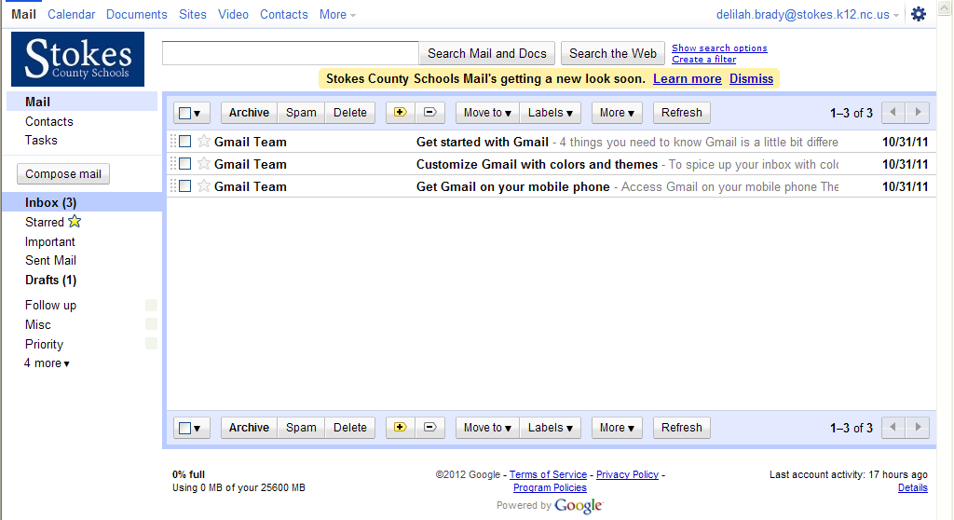
Contacts | Lists the email addresses of people you’ve corresponded with, you can add more details if you wish
Tasks | Let’s you enter and track “to-do” lists
Compose Mail | Opens a new message for you to send (if you need more help, see
Inbox | Shows your conversations (the number in the parenthesis shows the number of unread converstaions you have)
Starred | Shows you only messages you’ve marked with a star (use stars to mean whatever you like).
Important | Show you messages you have marked as important
Sent Mail | Shows messages you have sent
Drafts | Houses messages you’ve started and saved to work on later.
Follow up | BCC an email to yourself, then put a check mark beside of it, click followup for conversations you need to follow up on
Misc | To mark a conversation Miscellaneous
Priority | To mark a conversation Priority
More | List all your tags(your old folders). You can either have this whole list active or hide in the options
Chats | This lists your archieved chat conversations
All mail | Shows you almost all of your mail: you’ll see content from your inbox, starred, chat, sent, drafts, and all your archieved messages, you won’t see spam or trash.
Spam | Where mail is sent that looks suspicious
Manage Labels | A label is a folder on the left, the list you see
Create new label | Creates a new folder on the left

Navigation on top or bottom of mail
Empty box | This allows you to put a check in all the emails you want to group, allows you to all, none, read, unread, starred, and unstarred
Archive | Allows you to archive an email
Spam | Allows you to mark an email as spam
Delete | Allows you to delete an email
+/- | Allows you to mark an email as important/not important
Move to | Allows you to move to your label/folder
Labels | Allows you to Manage labels/folders
More | Allows you to Mark all as read, Mark as read, mark as unread, add to tasks, add star, remove star, create event, filter messages like these, mute, unmute
Refresh | Refreshes the screen to show new messages

