Stokes County Gmail: Composing Email
Click on the link provided on the school website or go to http://gmail.stokes.k12.nc.us
Enter
Username:
and
password

Navigation on the left side to  Compose Mail | 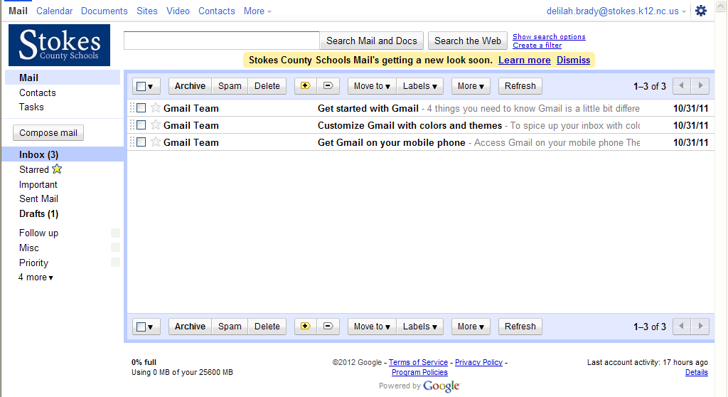
Notice autosave at the top.  Send, Saved, Discard  To  Add CC  Add Bcc  Subject  Attach a file  Insert Invitation to add to calendar | 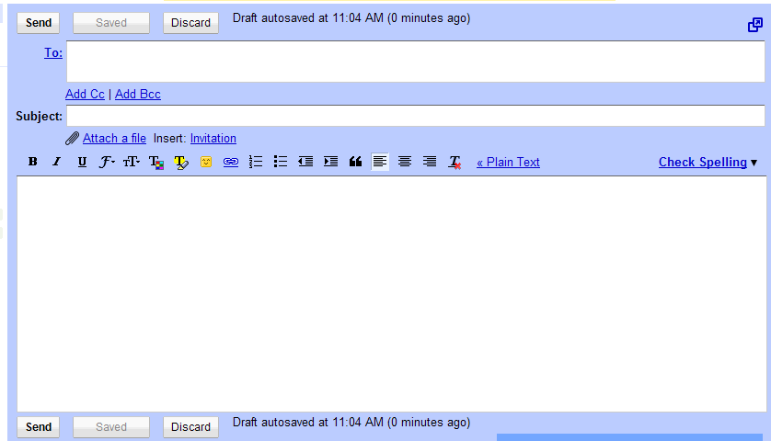  From left to right symbols: bold, italics, underline, font, size, text color, highlight color, insert emoticon, link, number list, bold list, indent less, indent more, left justify, center justify, right justify, remove formatting, convert to plain text, check spelling

