Stokes County Gmail: Calendar
Click on the link provided on the school website or go to http://gmail.stokes.k12.nc.us
Enter
Username:
and
password

Navigation to the top and click on Calendar
Create an event: | You can create an event in a number of ways:  Click and type to create an event  Click on the day where you'd like to create a new event. If the event spans over an hour, click and drag. Type the title and event time for your new event in the box. Finally, click Create event to publish the event to your calendar immediately, or click Edit event details to add additional information.  Create an event using the "Quick add" feature  Click on Quick add, or type the letter "Q," then enter your info--[ Dinner in North Beach 8PM Friday ], for instance.  Create an event using the "Create event" button  Just click on Create event in the left column of your calendar. This will bring you to a page where you can enter as much information as you'd like about your event. On this page, you can also add guests, change a reminder setting, and publish your event to other users. Once you've entered the appropriate information and selected the desired settings, make sure to click Save.  Create an event from the calendar list  In the calendar list on the left, click on the down-arrow button next to the appropriate calendar. Then, select Create event on this calendar.
Return to cal  Save  Discard  Title  Date  Repeat  Where  Who’s calendar  Description  Attachment  Event color  Reminders  Show me as  Add guest | 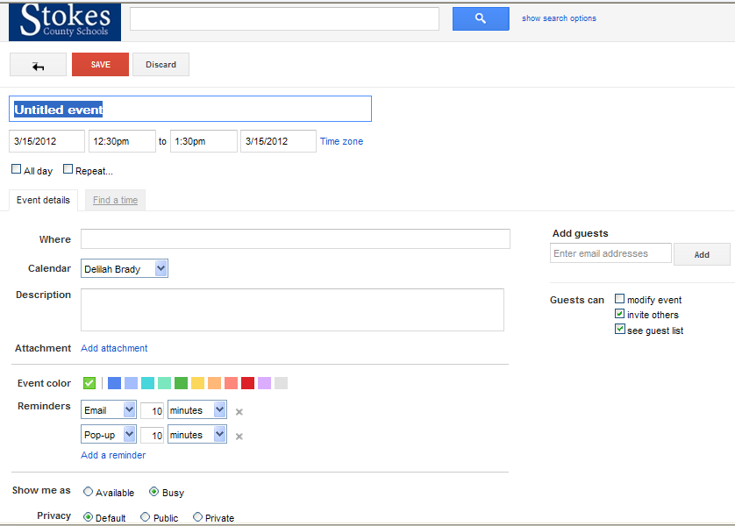
Delete or Remove an event | To delete or remove an event from your calendar, click the event to display the event bubble (alternatively, click on the event title to view the event details page). You'll then see a link or button to either remove or delete the event from your calendar.  Remove / Remove from this calendar  This option is only available for events that you are invited to and do not have permission to edit. Clicking this will remove the event only from your calendar. The event will still exist on the calendars of other guests as well as the event organizer.  Delete  This option is only available for events that you have permission to edit. Clicking this will remove the event from your calendar as well as the calendars of any invited guests. That is, the event will be completely deleted.  Keep in mind that it's possible after you've deleted an event for it to continue to exist on your guests' calendars. For example, if you're invited to an event and you invite additional guests to this event, deleting the event from your calendar does not also delete the event from the calendar of your invited guests. In order for the event to be removed from all guests' calendars, the original owner must remove the event. Additionally, after an event is deleted, it may not be removed from Google's servers immediately and residual copies of your calendar information may remain on backup media.  There are several options to consider when deleting a recurring event:  - To delete only one event in the repeating event series, select Only this instance.  - To delete all the events in the repeating event series, select All events in the series.  - To delete all upcoming events in the repeating event series, select All following.
Create a new calendar | - Click the drop-down arrow to the right of My calendars  - Select Create new calendar  - Enter information about your new calendar  - Click the Create calendar button  All of the calendars you create will be listed under My Calendars on the left side of your page. For each of the calendars, you can add, delete, and edit events any time you like.
Delete a Calendar | To permanently delete a calendar from your calendar list, just follow these steps:  - Click the drop-down arrow next to My calendars or Other calendars and choose Settings. (Alternatively, click the gear icon at the top of any Calendar page, click Calendar settings and then choose Calendars.)  - Click the Unsubscribe or Delete link next to the calendar you want to remove.  - Delete will permanently erase the calendar. (No one, including those who are sharing or subscribing to the calendar, will be able to access it anymore.)  - Unsubscribe will only remove your access to the calendar. (Others will still be able to use it normally.)  - Click OK.
Clear all events on primary calendar Clear all events on primary calendar | It is not possible to delete your primary calendar. You can clear all the events on your primary calendar, rename this calendar, and schedule new events to effectively replace your original primary calendar.  Here's how to clear all of the events on your primary calendar:  - Click the drop-down arrow next to My calendars and choose Settings. (Alternatively, click the gear icon at the top of any Calendar page, click Calendar settings and then choose Calendars.)  - Click the Delete link to the right of your primary calendar (the first calendar in the list.) You'll see this message: You are about to permanently delete all events on your primary calendar. This action cannot be undone.  - Select the checkbox next to Yes, I definitely want to delete all of the events on my calendar to acknowledge that all of the events on your primary calendar will be permanently deleted  - Click the Delete all events button.  Please keep in mind that it may take a few moments to fully access Google Calendar's features after clearing your primary calendar

Shortcut Key | Definition | Action
Navigation
k or p | Previous date range | Moves your calendar view to the previous date range
j or n | Next date range | Moves your calendar view to the next date range
r | Refresh | Refreshes your calendar
t | Jump to 'Today' | Moves you to the current day
Views
1 or d | 'Day' view | Displays your calendar in the 'Day' view
2 or w | 'Week' view | Displays your calendar in the 'Week' view
3 or m | 'Month' view | Displays your calendar in the 'Month' view
4 or x | 'Custom' view | Displays your calendar in the 'Custom' view
5 or a | 'Agenda' view | Displays your calendar in the 'Agenda' view
Actions
c | Create event | Allows you to create a new event
e | Event details | Allows you to view an event's details
Backspace or Delete | Delete event | Deletes the event
ctrl + z / command + z or z | Undo | Undo last action (if possible)
Application
/ | Search | Places your cursor in the search box
shift += or + | Add a calendar | Focus on 'Add a calendar' text box under 'Other calendars'
q | Quick add | Opens "Quick Add"
ctrl + p or command + p | Print | Prints the current view
s | Settings | Brings you to your Google Calendar settings page
ctrl + ? / command + ? or ? | Keyboard shortcuts menu | Brings up a menu of keyboard shortcuts

