Log in to thinkgate.net  Click on the link  Reporting | 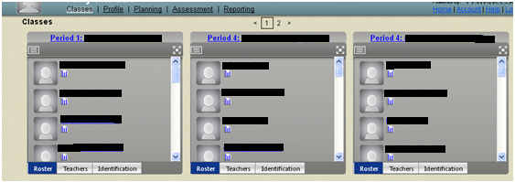
Click on the 4 way arrow in the top right corner under Assessment Results
Click on the quote box beside the word Grade, select the correct grade

Click the quote box beside the word Curriculum
Click the drop down arrow and select the subject
Click the quote box beside the word Category, take the check off All and put a check beside Benchmark and take the check mark off All
Click Search
Double click on the number to the right of the Period | 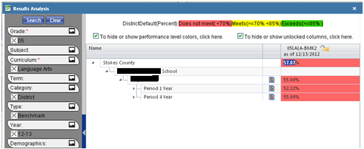
Select Distractor Analysis
Red shows incorrect answer, Green shows correct answer.  You can click the number at the top to see the question.  Click on the magnifying glass to see the standard. | 