Click assessment link

Under classroom assessment, click add new

Click Make it quick
Complete:
Grade
Subject
Course
Type
You only
have quiz and test types

Term
Content
Description

Click Continue
Drop down beside Standard Set
ccss class

if not cc then scs

Item Bank Drop Down:  Community is everyone in thinkgate, if you turn it off, you won’t have many items available.  Some items may not be good items.  Enter the number of each item you want.  Or: | 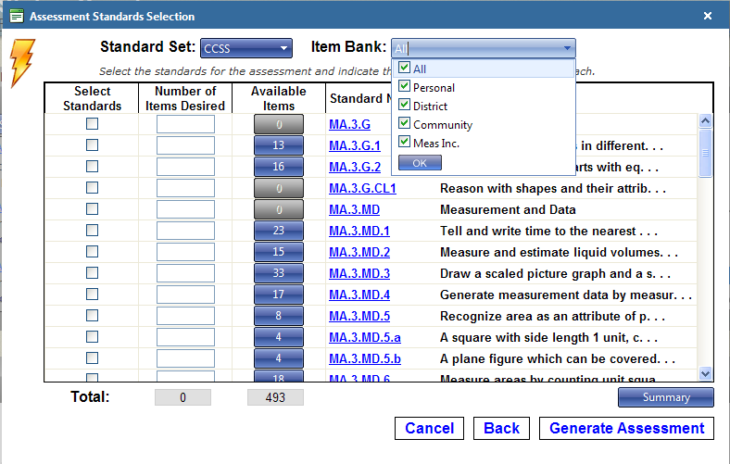
Click on a blue number, will give you the option of how many of each are in the total.

Can enter the number of each type you want

Click update
Click Generate Assessment
If you do not want the question, click red x on the left of the number.  Deletes the assessment completely  Makes a copy of the assessment  Online Preview of the Assessment  Print the Assessment  Reorder Items  Proof Assessment | 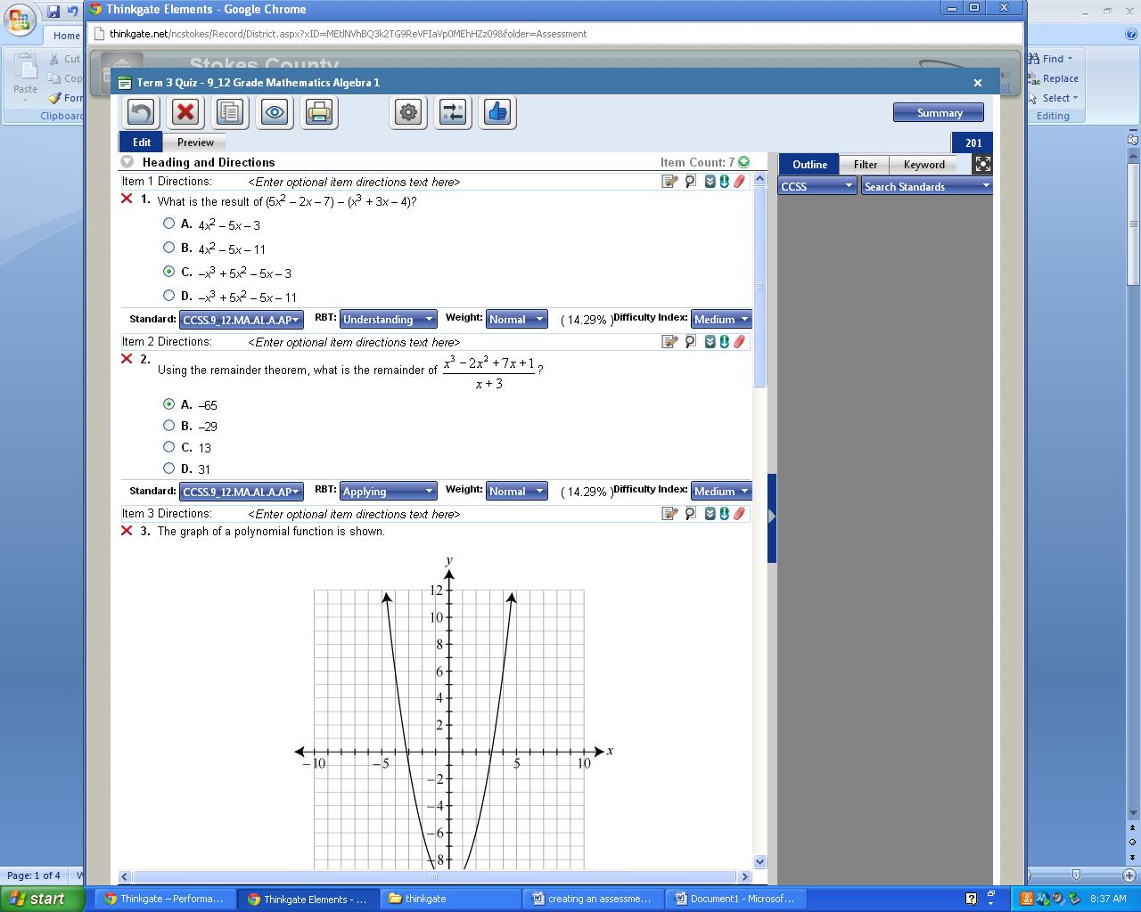
Click Blue Proof Assessment Thumbs Up Symbol
Attention Popup:

Click Proof Assessment
Blue Thumb changes to Green Thumb

Click white x on the right.
Under Classroom Assessments, you will see the assessment you created with a green thumb beside it

If you do not see it you will have to refresh the screen.

Click the space ship under the assessment
Put a check in the box of the test that says LALA or MAMA, not the HRHR

click Enable Online
Then Click OK

Click on the space ship beside the LALA test that you just enabled,
This will pull up a list of all students with the test code and the students’ id and log in id…

Right Click in the light blue area:
Select Print

This will give the teacher the student number and the
Student log in number. Either number will work for the student test.

At the top of the form is the Test Id Code that is needed for students

Make sure there is a green symbol and the word Enabled. This shows the assessment is ready to be given online.
On test day, this is the screen where you unlock a student if their tests lock.

If a student’s assessment locks:
Put a check in the box beside the student’s name and click the continue button.

If you need to stop a test and come back to it at a later time, put a check in the box and click suspend. Before re-starting the test, you will have to continue the test.

If you are continuing a test at a later time, the student must be at the same computer they originally started on.
Notes: | Make sure the pop up blockers are off…(This can be done the day of test)  Make sure there are no tool bars on ie, click x to get rid of it….(can be done the day of test)  If all the students that are in the testing session are denied logging in, have teacher log back in and make sure they clicked both boxes and clicked enable online.  Remind students not to minimize their screen once they log into a test.

