CPS Gradebook Setup:
Click the report tab, then gradebook tab. Click on Gradebook Setup.
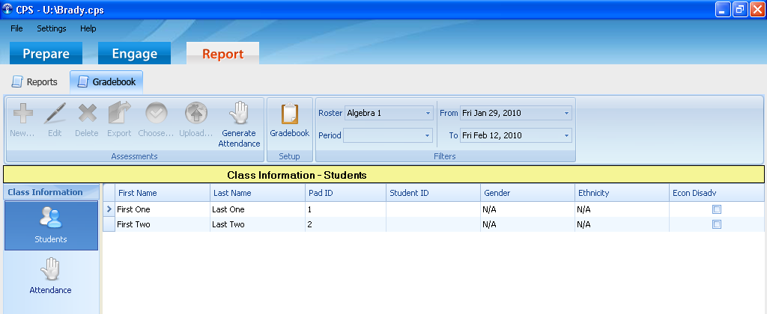
At the Welcome Screen, you can password protect your database, choose point-based grades, once finished with this screen, click next.
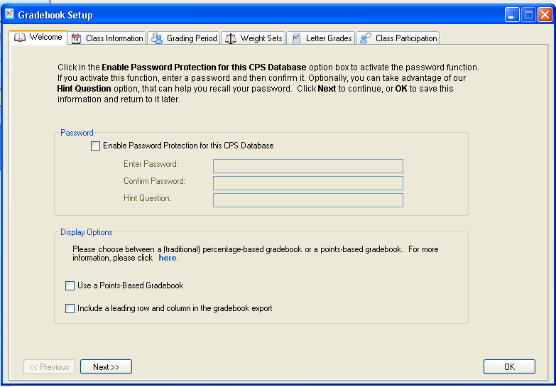

At the Class Information Screen, CPS will include all the classes you have assigned students into. Click next.
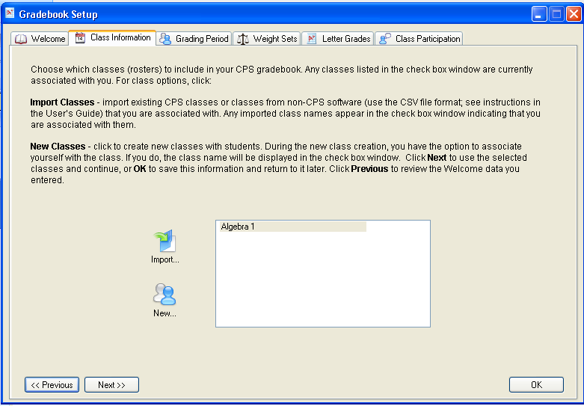
At the Grading Period Screen: Title will be the Quarter/Nine Weeks. To set the beginning date and end date, click the down arrow. Click next.
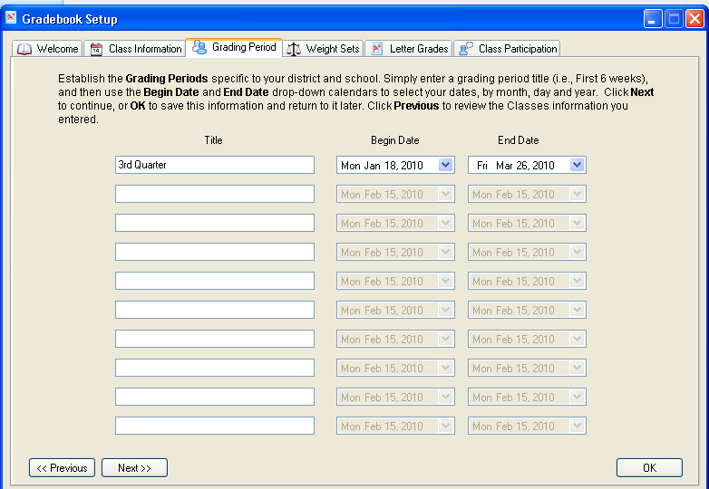

On the Weight Sets screen, there are already preset weight items, weight items based on your class. Weights have to add to 100. Click next when finished.
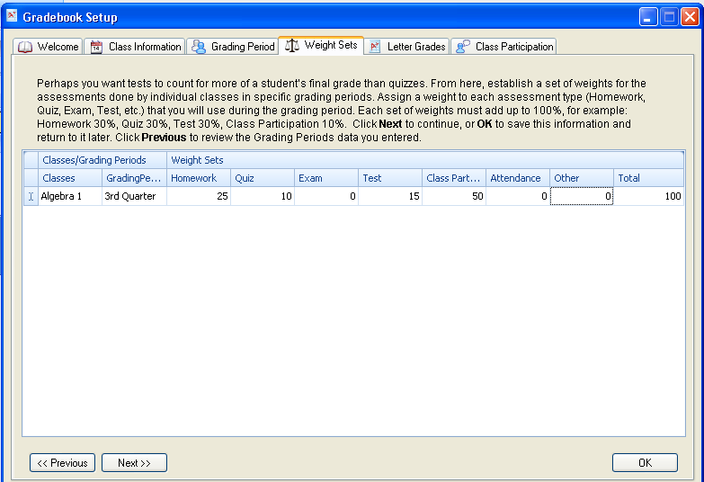
At the Letter Grade Screen: set bottom values for each letter grade, CPS does not accept decimal numbers. Click next.
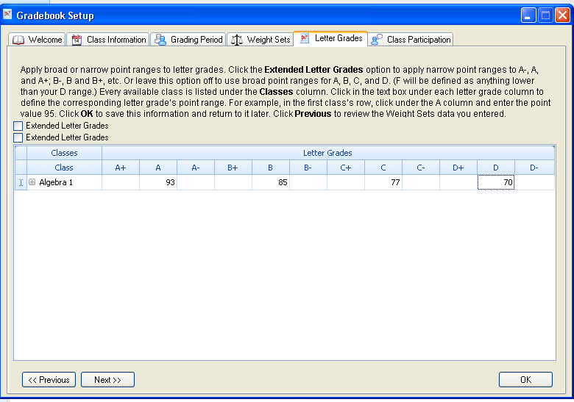

At the Class Participation screen, you decide if you want to reward students for participation during an assessment even if they got the question incorrect.
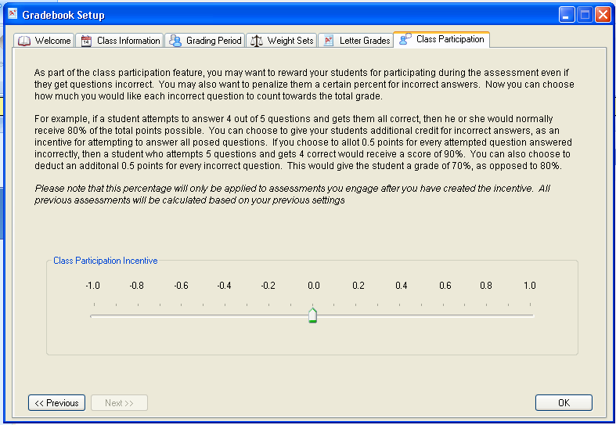
Click ok.

Taking attendance with CPS:
Click the engage tab; highlight the class you want to take the attendance in.
Click the Take Attendance button.
At the next window, click the start button.

