CPS Basics
Open CPS from the icon on the desktop:
Click the radio button on Create a new CPS database, click ok
File name: give it your last name
Save in U drive
Click Save
Saving to U drive cps doesn’t like, it could become unstable, click the yes button

You will get a cps html help screen
Click the red x
Creating a Class:
Click the Prepare tab
Click Classes & Students tab
Click the arrow under New, and select Class
At the new class wizard screen, click k-12 and next
Do you have a username and password for CPS Online? Click No and Next
At the Account Information Screen, Only type in your first/last name and email address, click next.
At the class information screen, Type in Class Name, Click next.

At the ready to save your information screen, click next.
If you want to create another class, put a check in the box and click done. Repeat Creating a class directions.
If you are finished with creating classes, do not put a check in the box and click done.

Adding Students to the Class:
Click the Prepare tab; Click the Classes & Students Tab, Click to highlight the class you just made.
Click the arrow below new and click student
The right side will open for input of students’ name. Type students’ First / Last name, CPS automatically assigns the student a clicker pad number. Use the tab key to go from first to last name. Use the enter key when you are ready to add a new student. Continue until you have added all your students. When you have finished adding all students, click Save.

To Create a Fast Grade Lesson : (For tests, quiz, Classscape, etc)
- Click the prepare tab.Click the lessons and assessment tab
- Click down arrow under New, click FastGrade Lesson.
In the Lesson Attributes Box, Give your fast lesson a Title, you can give a description if you want. Click Ok.
At the Fast Grade Screen
Click the correct answer choice for the multiple choice lesson you are planning. When you have finished entering all answers, click ok.
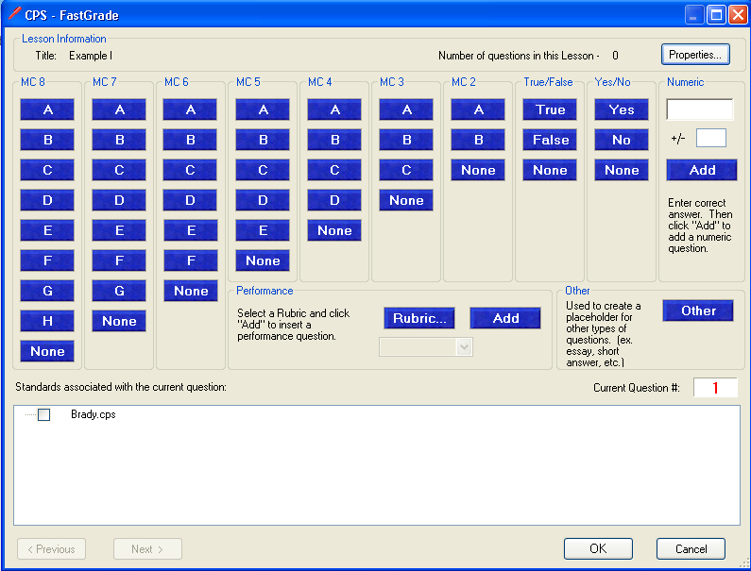
Click the Engage Tab
Put a check in the box for the Fast Grade you just created
Click Assessment Setup, Click Teacher Led or student let, Click Engage Assessment.
When you Engage Assessment, CPS will automatically minimize and you will see the Engage Bar at the top of your screen.
Click the options Button
At the delivery options screen, Take the check mark off the Show Large Screen, Click ok.
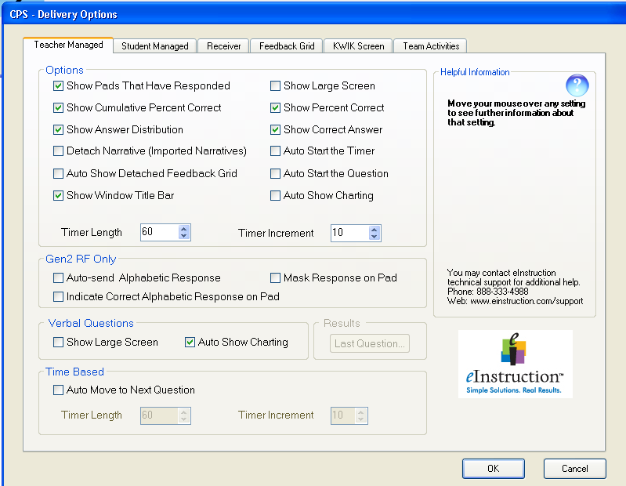
Click Start.

Bring up classscape
Log on to www.classscape.org
Two possible ways to use Classscape with CPS:
1.
When you are in classscape click the Assessments dropdown, click Schedule Assessment
On the next screen choose: subject area, assessment by objective, then click Preview Assessment, write down all the correct answers, just the letters. Then Click Preview w/o Keys. Do not close after this, just minimize to get it out of your way.
2.
Create a generic student when you set up your class.
Use the generic student ‘s log on to deliver the questions.

Arrange your screen so you can see both CPS and Classscape at the sametime.

