Directions for converting information in comma separation to a table, then editing, pasting into excel and scatter plotting.
- Open Earthquake Info file.
- Highlight all the information | 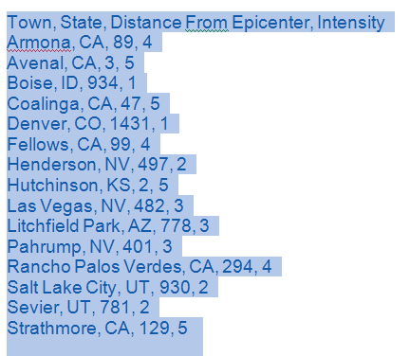
- Click the insert tab | 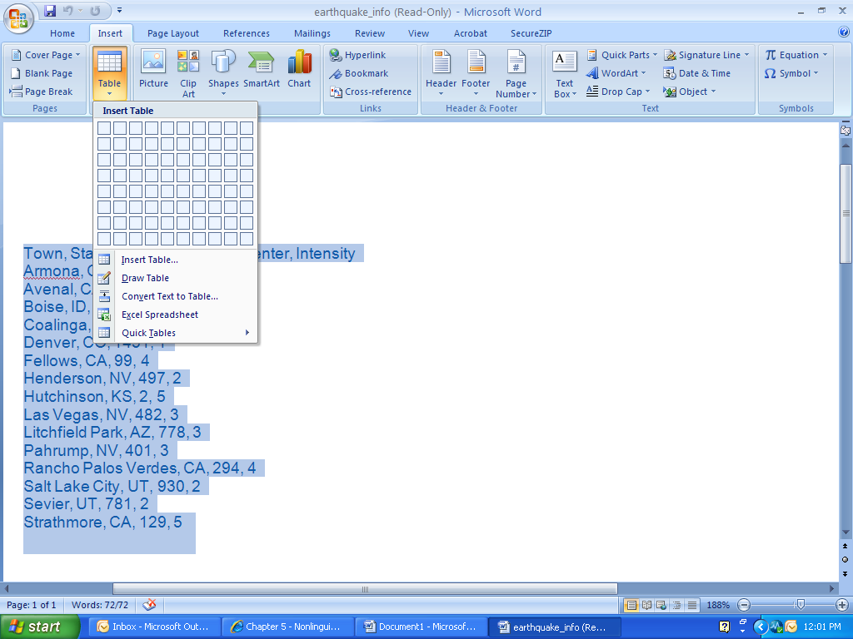
- Click the Drop Down Arrow under Table, select Covert Text to Table.
- Put number of columns to 4 for this example and make sure there is a radio button check beside Commas. Click OK. | 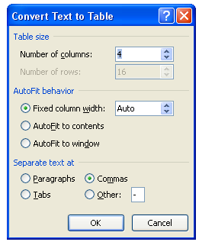
- Delete the Columns Labeled Town and State. | 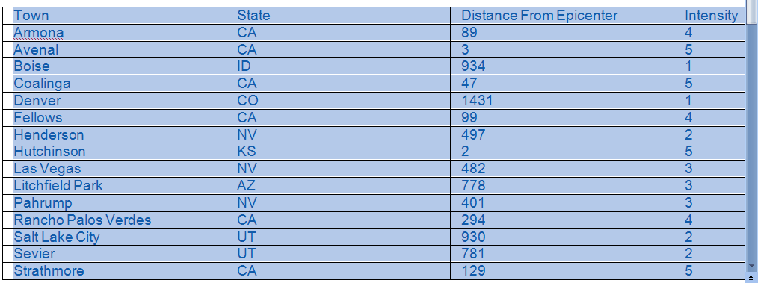
- Highlight the remaining 2 columns, right click and copy. | 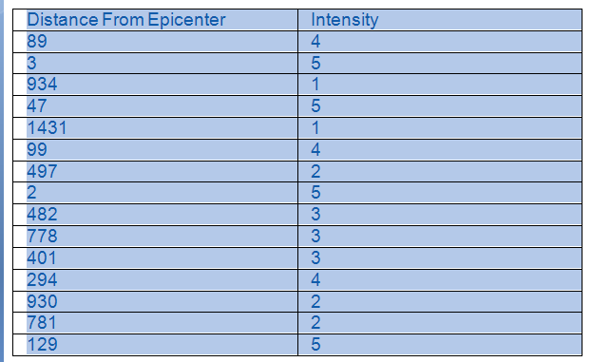
- Open excel, right click paste. Make sure both columns are still highlighted. | 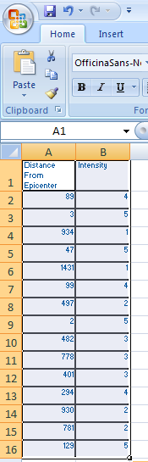
- Click the Insert Tab, Click Scatter Dropdown arrow, select Scatter plot without lines. | 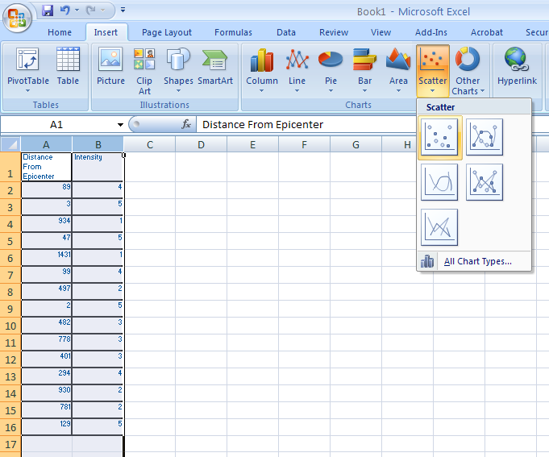
- This gives students a visual of the information in the chart. | 

