Go to www.blabberize.com
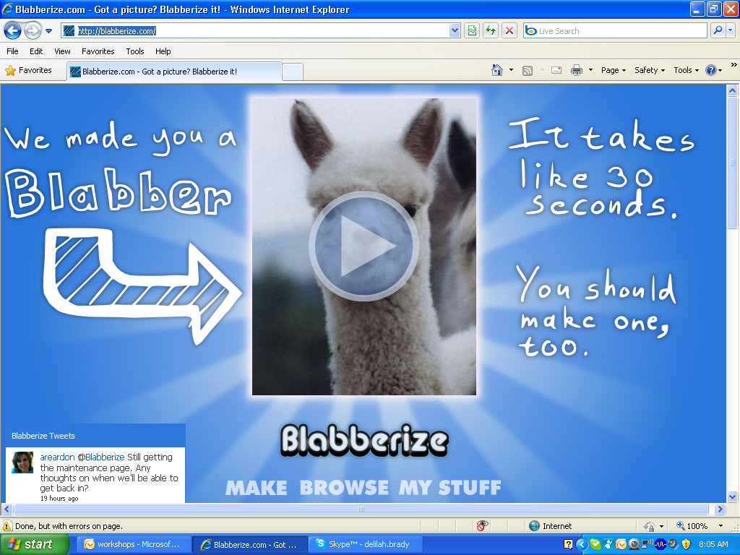
Click the word Make at the bottom of the screen
Click the button Browse
The picture you selected will show. Scroll to the bottom of the screen, Click the blue arrow.

On the next screen, you will be adding the mouth outline, Place the blue and green dots around the area of the mouth.
Click the blue arrow at the bottom.
On the next screen, you will have options for sound
Microphone, Upload something already recorded, record using your telephone.
Click Microphone, On the next screen, click the red circle to record, once you have finished click the blue triangle beside it. It will play what you recorded. When you are satisfied with the recording, click the blue arrow to go to the next screen.
On the next screen, click the pink arrow to play your recording, click ok when satisfied with recording.

On the next , select if you want to make another scene, edit scene, or save your scene. You will have to create an account or log on your account to save.

To create a blabberize account:
Open www.blabberize.com
Scroll down to the middle of the page, click on the word signup
On the right side under sign up: make yourself a username, you have to include your email address, type your password 2 times. Click sign up button.
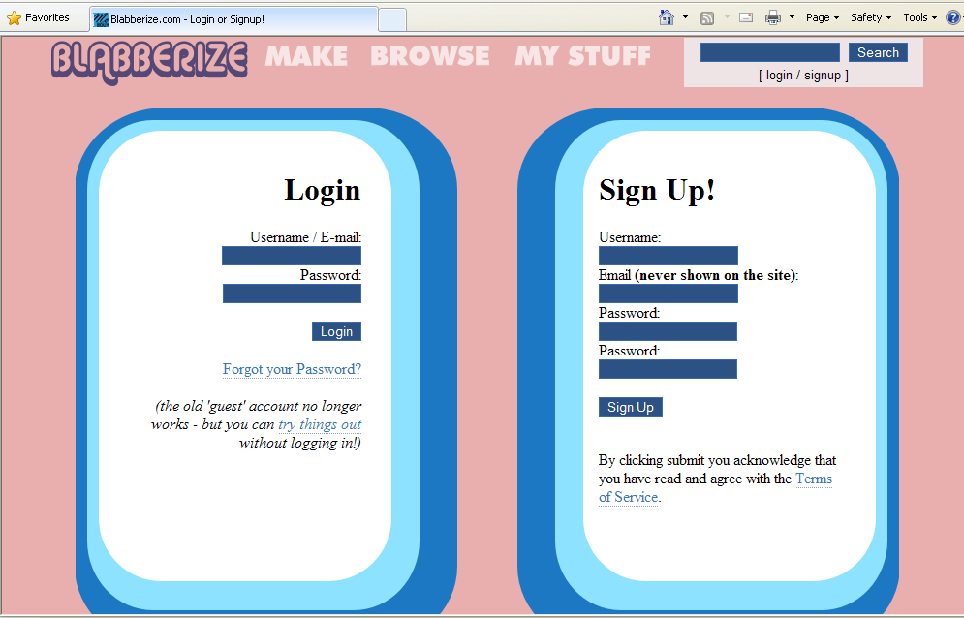
The only way you know your account is ready is by the small pop up sentence.
On the left side of the screen, below login: type username and password. Click Make at the top.

