Animoto.com
Click new user sign up now
Type in your email address
Create a password, type password 2 times
About you: first name, last name, country, zip code, birthday, male/female
Click sign up
Log into www.animoto.com
Click Create Video at top left.
Click Short 30 second video.
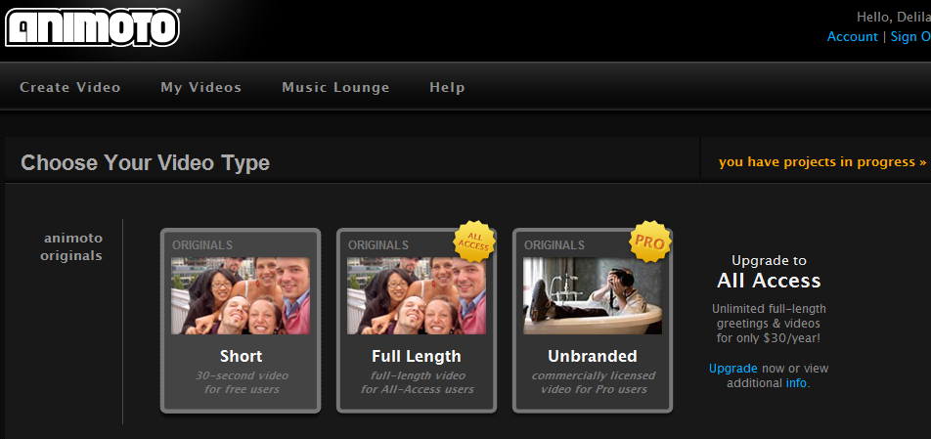
Click create video
Step 1: pics & vids: Click upload from your computer.
Browse to the location of your pictures.
You can highlight all your pictures at one time to upload.
Once you have finished uploading all your pictures, click done.

Step 2: music: select from their music or upload your own. For this workshop, click Select.
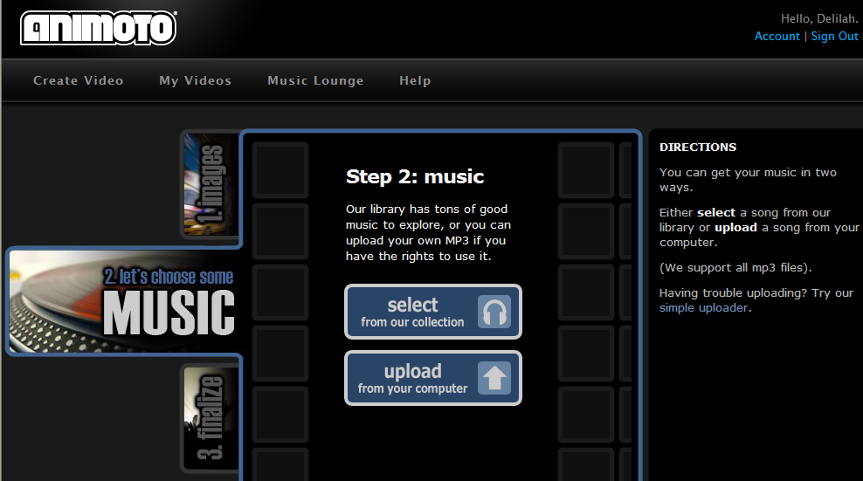
Choose a genre by clicking.
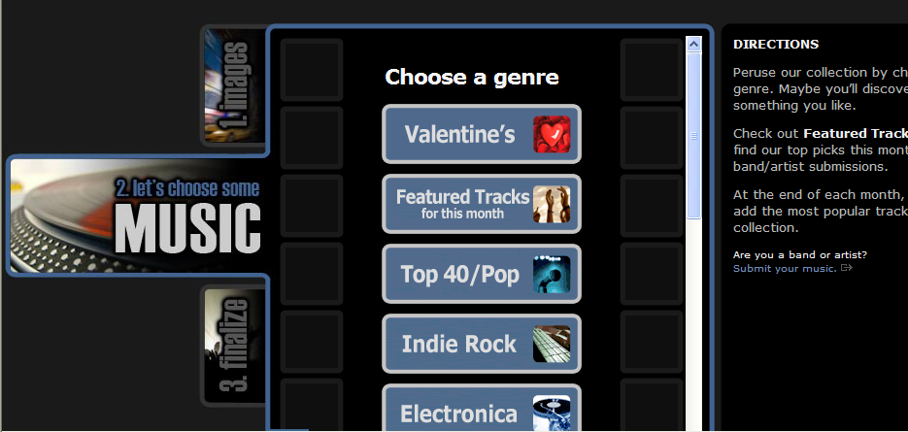
Click the play button to hear the music. If you want to include it in your project, click select.

Customize your video, by length, image pacing, video cover screen. Click continue when finished.
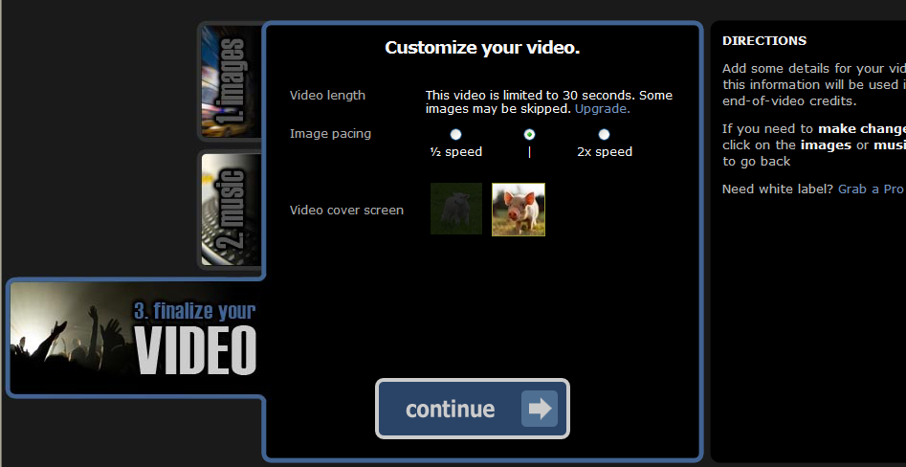
Give your video a title, description, producer name. Click create video.
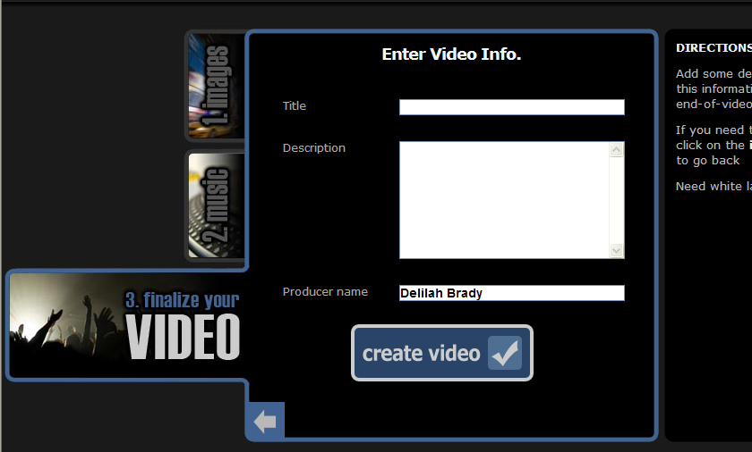

When it is processing your video, you can create more or exit the program. It will email you a link to the video.
