Animoto.com
Click Get Started
Click new user sign up now
Type in your email address
Create a password, type password 2 times.
About you: first name, last name, country, zip code, birthday, male/female
Click sign up
Choose type of video
30- second video free
Full length $30.00 a year
Unbranded for commercially licensed

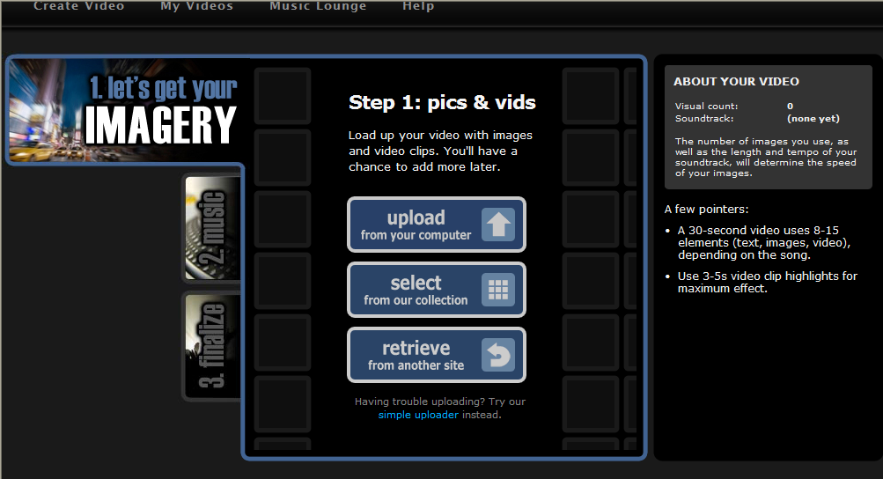

Animoto for Educators
http://animoto.com/education
In order to sign up (or re-sign up) as an educator for a free all-access pass, you can apply for a code from http://animoto.com/education
http://animoto.com/education/signup
Your application will be processed in the order it was received! Make sure you add education@animoto.com to your address book so that your confirmation doesn't end up in your spam box.
Educational Accounts expire every six months, and you'll need a new code to renew your account. Also, once you've received the code, you have one month to redeem it.

How to set up accounts for your students?
You can set up your students' accounts by registering an e-mail address at gmail.com.
Once you have that original e-mail address registered at Gmail.com, you can then register for your students at the site by entering the following e-mail addresses in the registration form. Please make sure you are registering your students using the Classroom Code Link provided for you. If you don't, then the students won't have All-Access.
For example, you'd register the following e-mail addresses at Animoto:
emailaddress+1@gmail.com
emailaddress+2@gmail.com
emailaddress+3@gmail.com
emailaddress+4@gmail.com
emailaddress+5@gmail.com
All activity at animoto under these accounts will be sent to your original, derivative e-mail (i.e. emailaddress@gmail.com). This way, you'll be able to give each student a unique Animoto account, while also being able to monitor their account's activity.
http://animoto.com/education/getting_started

Getting Started with Animoto for Education
Your Classroom Code is your key to using your All-Access pass and producing videos for assignments and presentations at your school. It will give you full-length video making capabilities.

Step-by-Step
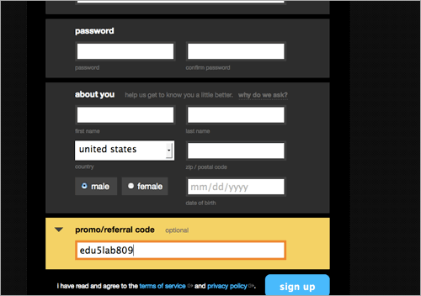
Your classroom code will only work when registering at Animoto. Do not register without your code.
Go to our sign up page to register with your Classroom Code.
If you are already registered at Animoto, you cannot use your Classroom Code.
- Enter your information into the sign-up form.
- Before you submit the form, click on the "Promo/Referral Code" section and enter your Classroom Code here.
- Submit the form and you are ready to begin using Animoto for Education in your classroom.

