- Click the Microsoft Office Button
- click Word Options at the bottom of the dropdown. 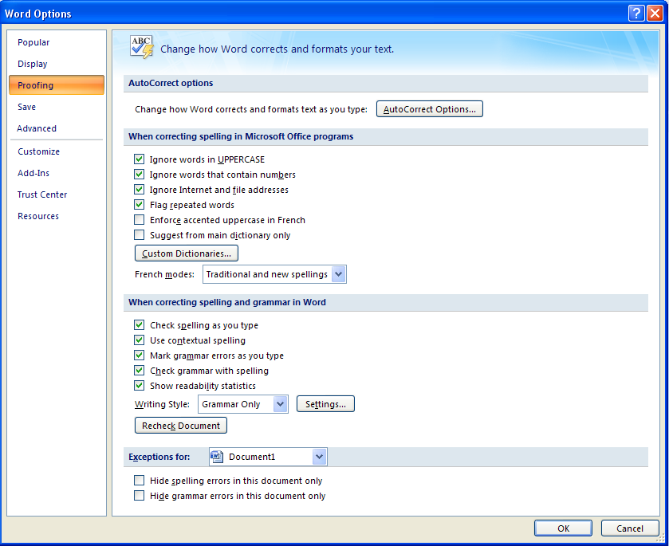
6.
5.
4.
3.
- Click Proofing.
- Make sure Check grammar with spelling is selected.
- Under When correcting grammar in Word, select the Show readability statistics check box.
- Click ok.
After you enable this feature, open a file that you want to check, and check the spelling. When Word finishes checking the spelling and grammar, it displays information about the reading level of the document.

